Cool-Season |  |  |  |  |  | Warm-Season
 | Broadleaf
Grass | Brassica |  |  | Legume |  |  |  |  | Grass
Annual Ryegrass |  |  |  |  |  |  |  |  | Teff
Winter Cereal Rye | African Cabbage | Phacelia |  |  |  |  |  | Buckwheat | Millets
Triticale | Forage Brassicas | Plantain |  | Alfalfa | Perennial Clovers |  | Sunn Hemp | Safflower | Sorghum Sudan Species
Oat | Kale | Flax |  | Sweet Clover | Annual Clovers |  | Guar | Sunflower | Grain Sorghum
Wheat | Rape Seed | Beet |  | Lentils | Peas |  | Mung Bean | Okra | Corn
Barley | Turnip |  |  | Vetch | Chickpea |  | Cowpea | Cucurbits
 | Forage Collards |  |  |  | Faba Bean |  | Soybean
 | Mustards
 | Radish
Cover Crop Periodic Table

Version adapted from the Cover Crop Chart USDA-ARS, Mandan, ND; Liebig et al., 2013
Annual Ryegrass (Lolium multiflorium)
- Cool-season grass - annual
- Seeds per pound: 190,000
- Upright growth
- Good livestock feed
- Rapid growth
- Extensive fibrous root system
- Winter hardiness is not as good as winter cereal rye
- May have potential weedy tendencies in small grain crop rotations

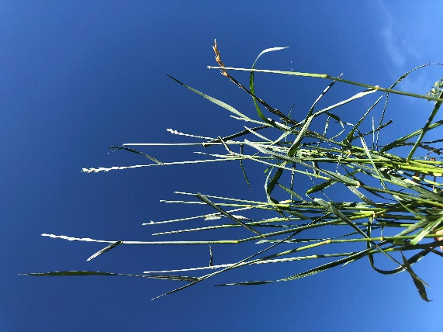 |  | 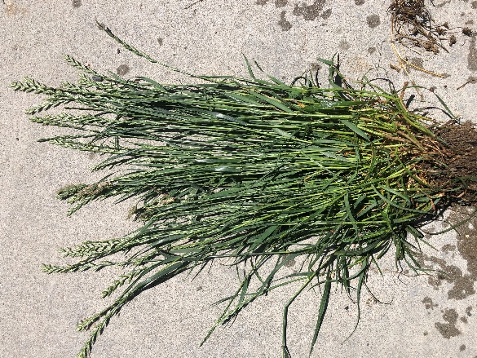
Fig. 1: Annual Ryegrass |  | Fig. 2: At Maturity

Return to Top

Winter Cereal Rye (Secale cereal L.)
- Cool-season grass - annual
- Seeds per pound: 18,200
- Winter types that need to vernalize prior to stem elongation and flowering, most varieties have awns
- Good salt tolerance
- At maturity can have high C:N ratios – provides good soil armor
- Fibrous root system, aggressive and deep
- Does have allelopathic effects, so excellent for weed suppression particularly with pigweed species such as; Palmer Amaranth & Horseweed
- Best as early spring grazing since feed value deteriorates quickly with maturity palatability decreases with maturity

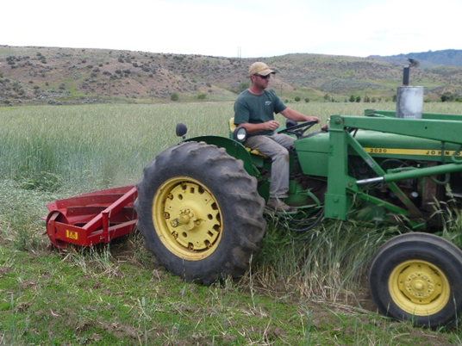 |  | 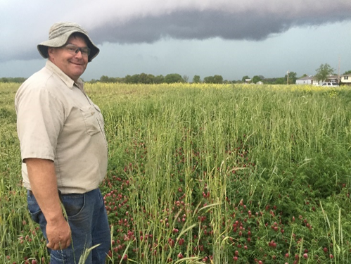
Fig. 3: Rolling winter cereal rye with crimper roller |  | Fig. 4: Winter cereal rye, crimson clover, hairy vetch mix
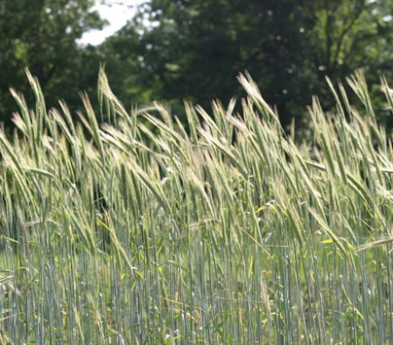 |  | 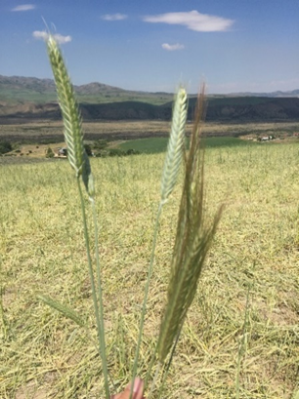
Fig. 5: Mature winter cereal rye |  | Fig. 6: Triticale head on left, cereal rye on right

Return to Top
Triticale (Triticale hexaploide Lart.: Triticosecale rimpaui Wittm.)
- Cool-season grass - annual
- Seeds per pound: 15,500
- Spring and Winter types- Awn-less forage types available, winter types can be planted in spring that will stay vegetative all through the season
- Excellent over-wintering ability for winter types
- Awned types will reduce palatability when grazed
- Excellent fibrous root system like all small grains
- Good salt tolerance, performs well in stressful conditions
- High feed quality when grazed in the boot, will regrow if flash grazed
- Produces more forage than wheat
- Superior to winter cereal rye for later spring grazing as it grows later in the spring

 |  | 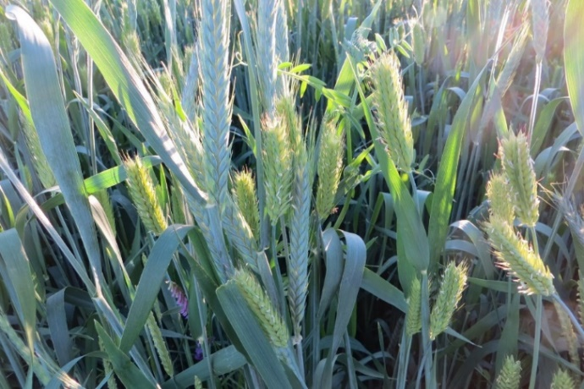
Fig. 7: Vegetative triticale 30 days after planting |  | Fig. 8: Mature triticale (blue green) and beardless barley
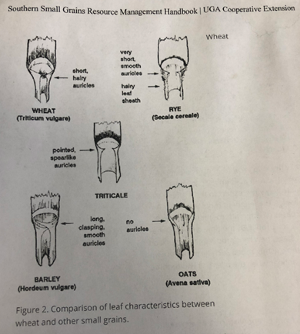
Fig. 8.1: Small grain identification
Return to Top

Oat (Avena sativa L.)
- Cool-season grass - annual
- Seeds per pound: 15,000
- Vertical growth habit
- Forage and grain producing types available, no awns, excellent feed value, highly palatable for livestock
- Black oat is a forage type, high biomass, seed produced in long season climates. Holds feed value into the winter.
- Blacks oats will overwinter in mild winter (southern U.S.) climates
- Spring types most common, some winter varieties survive in warmer climates
- Performs well in mixes
- Fibrous root system, good nutrient scavenger, may have some concerns of nitrate toxicity if mis-managed
- Poor salt tolerance, low heat tolerance

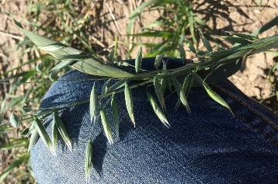 |  | 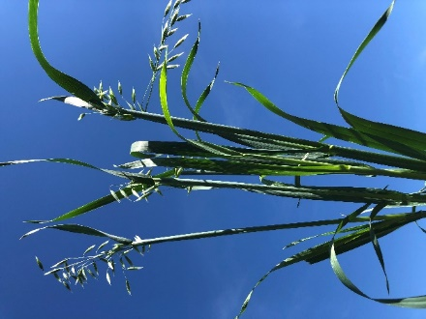 |  | 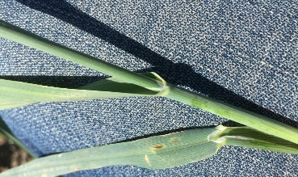
Fig. 9: Seedhead detail |  | Fig. 10: Mature oat plant |  | Fig. 11: Close-up of leaf and stem
 |  | Fig. 12: 24 days after planting

Return to Top
Wheat (Triticum aestivum L.)
- Cool season, grass - annual
- Seeds per pound: 14,000
- Vertical growth
- Spring and winter varieties, winter varieties planted in spring or summer will stay vegetative
- Forage types are awn less, varieties that have awns have lower palatability when grazed
- Forage types generally have more and wider leaves, forage types had 5 leaves per stem compared to triticale that had three leaves
- Good feed value when grazed
- Good salt tolerance
- Fibrous root system

 |  | 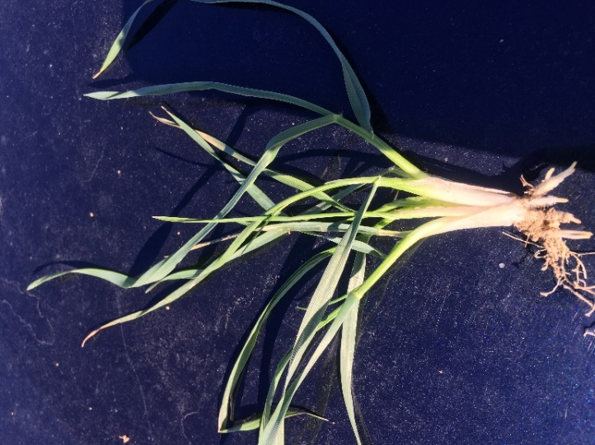
Fig. 13: Willow creek forage winter wheat |  | Fig. 14: 2 months growth
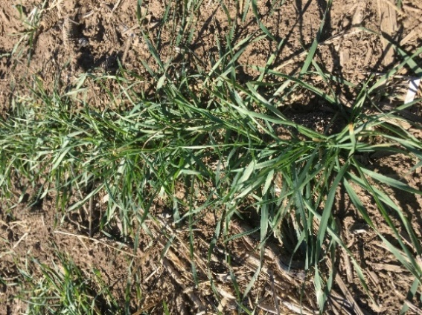 |  | 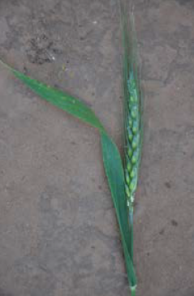
Fig. 15: 2 months growth |  | Fig.15.1: Bearded type
Return to Top
Barley (Hordeum vulgare L.)
- Cool-season grass - annual
- Seeds per pound: 13,000
- Shorter life cycle than other small grains, in mixes will mature earlier than other grains
- Vertical plant structure
- Very good salt tolerance
- Forage or hay varieties are generally awnless, most grain types have awns, Awns can make mature barley unpalatable
- High palatability and feed quality
- Spring and winter types, winter types are the least winter hardy of all the small grains
- Not as winter hardy as wheat, triticale or winter cereal rye – above-ground biomass often dies back in winter then regrows in spring
- Maintains forage value after heading out
- Fibrous root system
- Like other small grains good for wildlife feed and habitat

Fig. 16: 30 days after planting |  | Fig. 17: Beardless barley

Return to Top

African or (Ethiopian) Cabbage (Brassica carinata)
- Cool season, broadleaf - annual
- Seeds per pound: 180,000
- Tall, upright, branching structure
- Good deep tap root,
- Prolific flower production, provides pollen and nectar for predator insects and bees
- Fast growth, will often complete life cycle before other species in the mix
- Large leaves, Good feed value

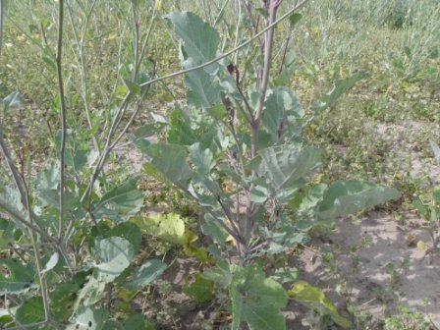
Fig. 18: 109 days after planting |  | Fig. 19: 30 days after planting
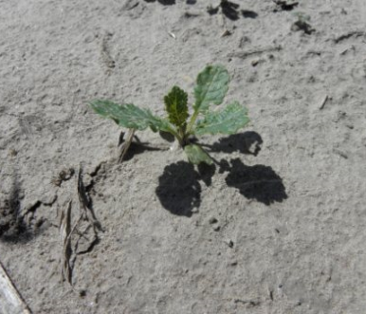 |  | 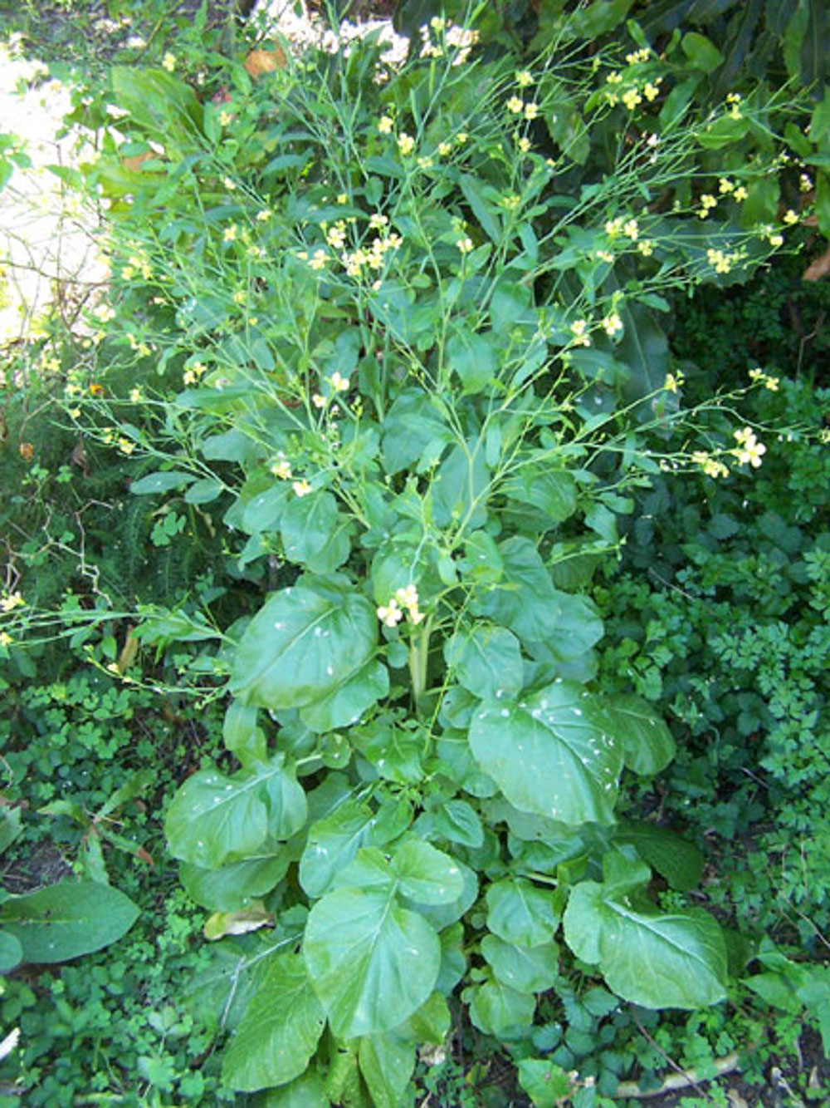
Fig. 20: 42 days after planting |  | Fig. 21: Mature plant with blossoms

Return to Top
Hybrid Forage Brassicas – various types
- Cool Season, Broadleaf- annual
- Selected for forage value and high leaf yield
- These forages are generally a cross between Turnip, Kale or Rape
- Hybrids generally are higher priced due to proprietary genetics
- Good Tap roots and very leafy, will scavenge deep nutrients
- High quality feed, goes well in mixes that have high C:N ratios
- In the Mustard family with generally low Mycorrhizal associations
- Generally poor salt tolerance
- Fast emergence and growth, be careful to not seed too thick in mixes as they will dominate

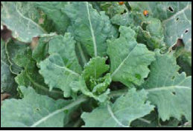 |  | 
Fig. 21.1 Plant |  | Fig. 21.2 Blossom
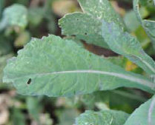
Fig. 21.3 leaf

Return to Top

Kale (Brassica oleracea)
- Cool season broadleaf - annual
- Seeds per pound: 175,000
- Many varieties, some will overwinter in mild climates
- Tap root
- Grows well in cool seasons
- Flowers for pollinators and predator insects
- High quality grazing forage, good micronutrient content
- Low mycorrhizal association

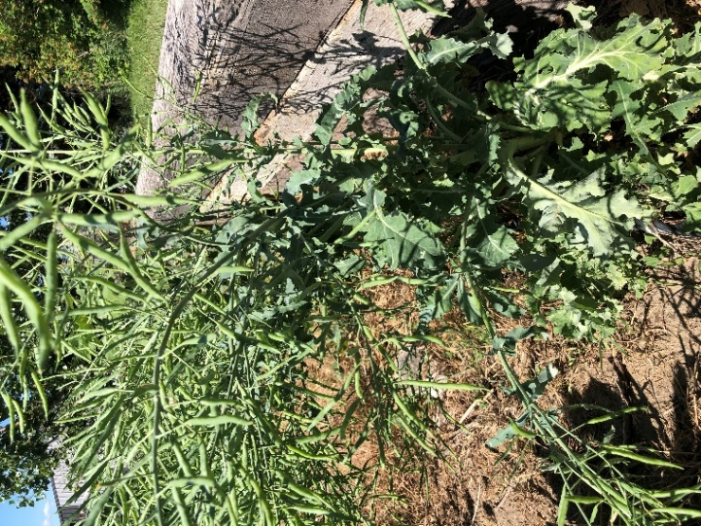 |  | 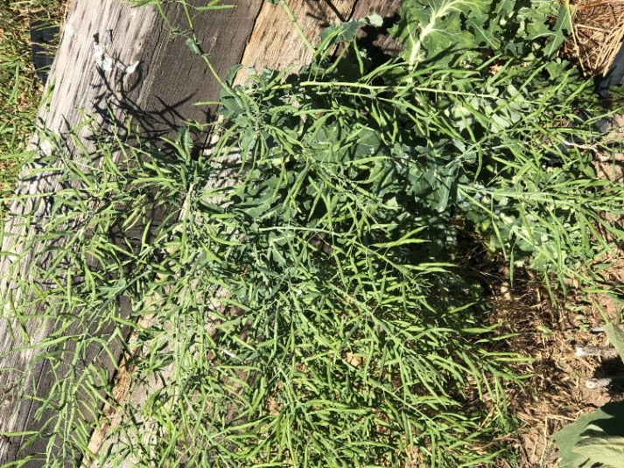
Fig. 22: Mature Kale |  | Fig. 23: Kale over wintered (Casper, WY) and by June 25th is setting seed
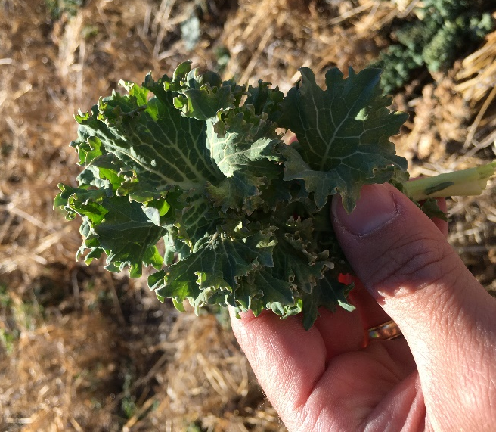
Fig 23.1: Kale leaf after frost (Kansas)
Return to Top
Rape Seed (Brassica napus)
- Cool season broadleaf - annual
- Seeds per pound: 175,000
- Can grow 3-5 feet tall
- Tap root, with branching tap roots
- Rapid growth
- Prolific flower production, Indeterminate flowering
- High livestock utilization and good protein and feed value
- Flea beetles often a pest
- Similar to Canola but not a GMO plant

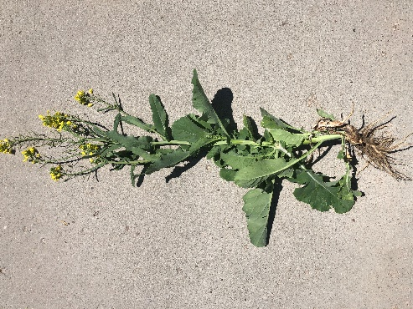 |  | 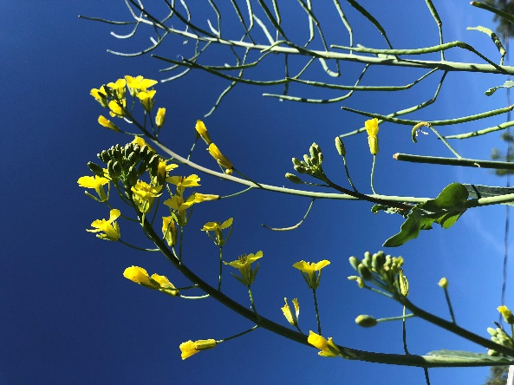
Fig. 24: Mature plant with root |  | Fig. 25: Prolific flower production
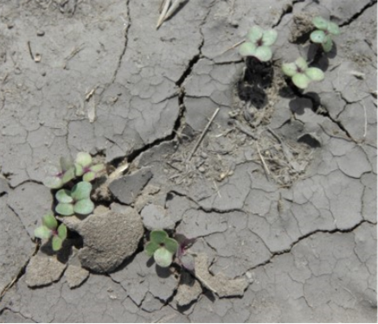 |  | 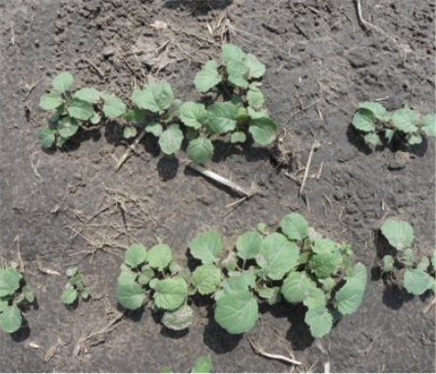
Fig. 26: 6 days after planting |  | Fig. 27: 15 days after planting

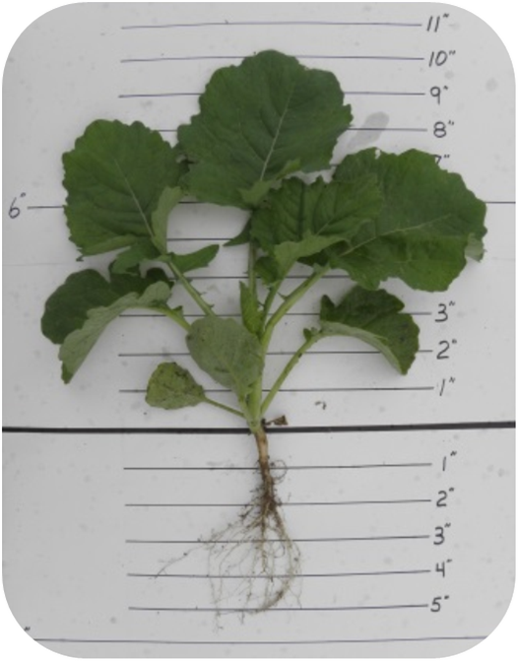
Fig. 28: 30 days after planting

Return to Top

Turnip (Brassica rapa)
- Cool season broadleaf - Biennial
- Seeds per pound: 175,000
- Winter kills in cold climates
- Will not flower the first year, good biomass accumulator
- Short, leafy with large bulb type root
- Forage value high, even if tops freeze, livestock will eat frozen roots, good for late season grazing,
- The root decomposes slower than a radish root
- Poor salinity tolerance
- Quick germination, and fast growth
- Shallow tap root
- Bitter taste during heat of the summer, palatability very good in late fall

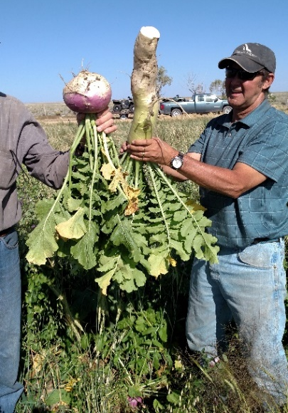 |  | 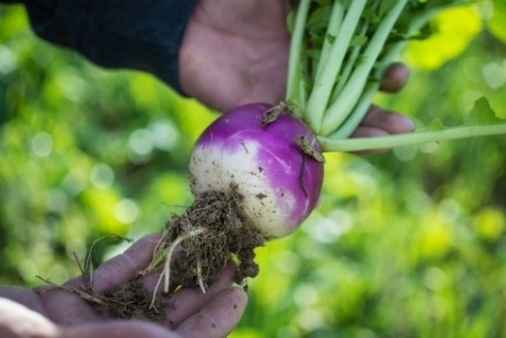
Fig. 29: Mature turnip and radish |  | Fig. 30: Purple top turnip root
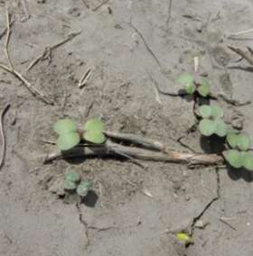 |  | 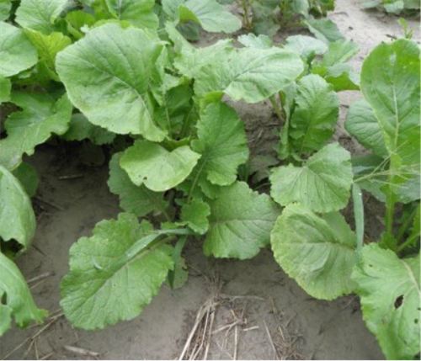
Fig. 31: 6 Days after planting |  | Fig. 32: 30 Days after planting

Return to Top
Forage Collards (Brassica oleracea)
- Cool season broadleaf - Biannual,
- Seeds per pound: 175,000
- Needs to over winter to produce seed– winter kills in cold environments
- First year stays vegetative and very leafy
- Provides high livestock nutrition (20 % protein), and stays green well into winter
- Generally winter kills in northern regions of US
- Tap root that branches

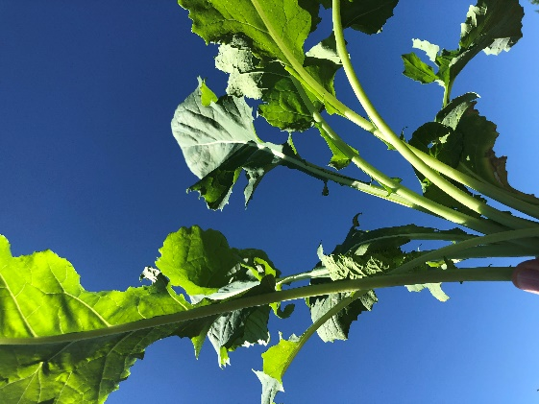 |  | 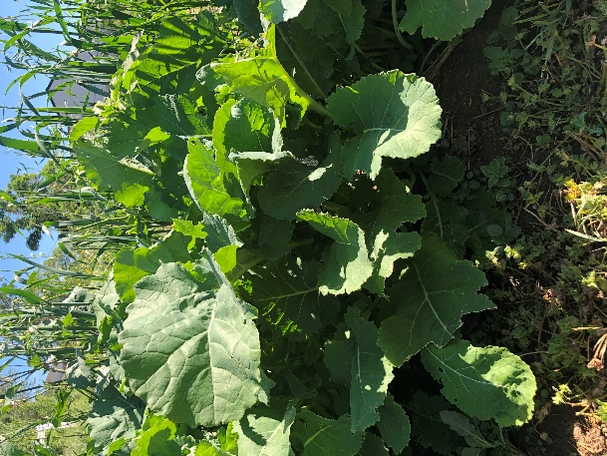
Fig. 33: Collard leaves and stem |  | Fig. 34: Forage collard plant

Return to Top

Mustards (Brassica spp.)
- Cool season broadleaf- annual
- Seeds per pound: 100,000 – 283,000 various
- Produces glucosinolates, has pungent flavor and may limits grazing value during hot parts of the season
- Has better palatability later in the fall
- Tall upright, branching stems
- Many varieties such as: Yellow, Brown, Oriental, Florida Broadleaf
- Salt tolerance poor
- Fast germinating and quick to mature, often will drop seed when grown in full season mixes
- Good tap roots with branching lateral roots for making bio-pores and deep compaction relief
- Prolific flowering
- Blooms approximately 30 growing degree days after planting regardless of daylength
- Low mycorrhizal associations
- Some varieties used as biofumigants or trap crops in sugar beets, potatoes or other crops

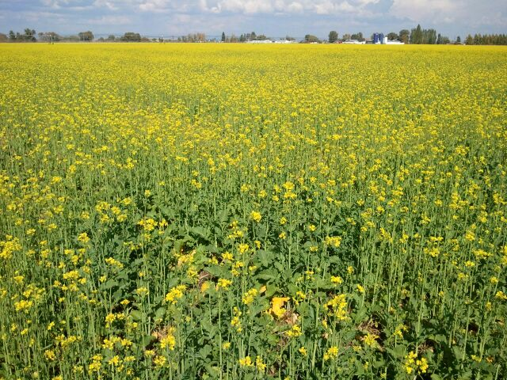 |  | 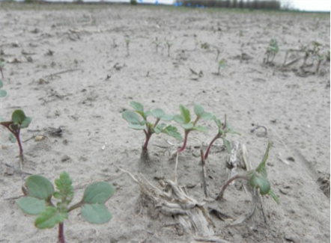
Fig. 35: Mustard planted for biofumigant |  | Fig. 36: 30 days after planting
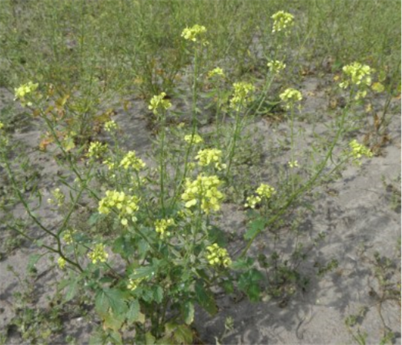
Fig. 37: 109 days after planting

Return to Top
Radish (Raphanus sativus)
- Cool season broadleaf - annual
- Seeds per pound: 25,000
- Few grazing types are Biannual
- Dominate tap root, some varieties branch more than others (oil seed). Oil seed types generally used for nematode trap crops
- Bolts when flowering can reach heights of 3 feet. When radish bolts it reduces tap root size
- Poor salt tolerance
- Good feed value in fall time, during summer months can have strong bitter taste
- Livestock generally do not pull the root up and eat it like a turnip, as it is anchored deep in the soil
- Excellent tap root to scavenge nutrients
- Some varieties act as Trap crop for nematodes
- Prolific flowers that attract insects

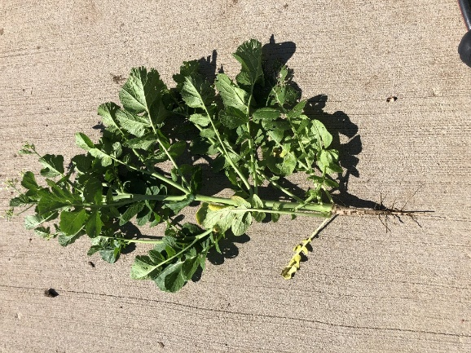 |  | 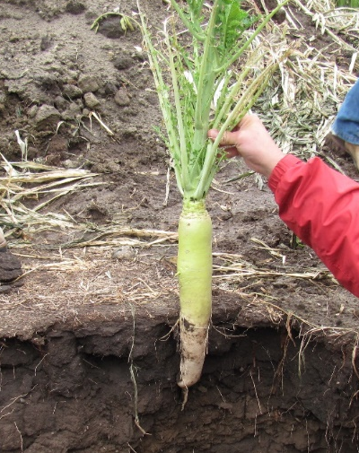
Fig. 38: Bolted Radish |  | Fig. 39: Tap root, with grasshopper damage on tops
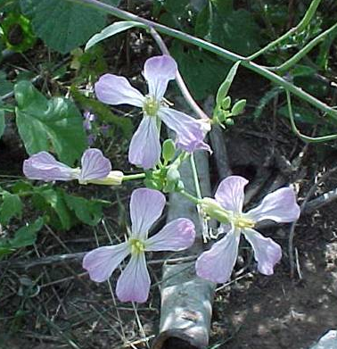 |  | 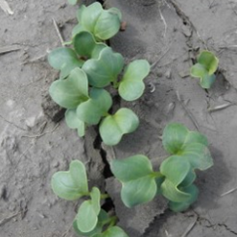
Fig. 40: Flower Detail |  | Fig. 41: 6 days after plant
Return to Top
Phacelia (Phacelia tanacetifolia Benth.)
- Cool Season broadleaf - annual
- Seeds per acre: 225,000
- Prolific seed producer
- Moderate tap root, will branch out
- Prolific flower production, excellent attraction for insects
- Low salinity tolerance
- Livestock graze it well
- Upright plant growth, 1 -2 feet tall

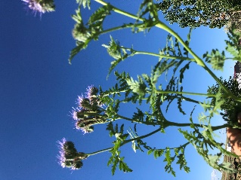 |  | 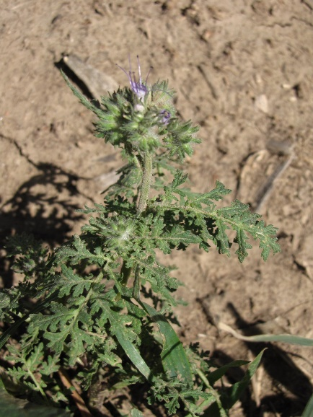
Fig. 42: Indeterminate flowering |  | Fig. 43:
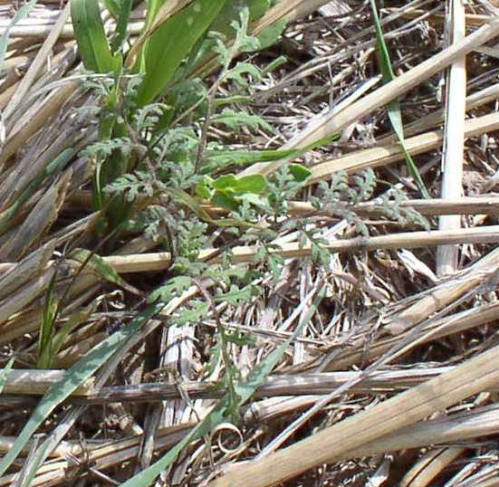
Fig. 44: In a mix in Western KS
Return to Top
Plantain (Plantago lanceolata)
- Cool season broadleaf- perennial
- Seeds per pound: 200,000
- Upright growth habit
- Deep tap root with dense branching tendency
- Excellent deep scavenger of micronutrients
- Often used in pastures for sheep and cattle
- Natural antibiotic properties and natural de-wormer for livestock
- Nutrient dense forage

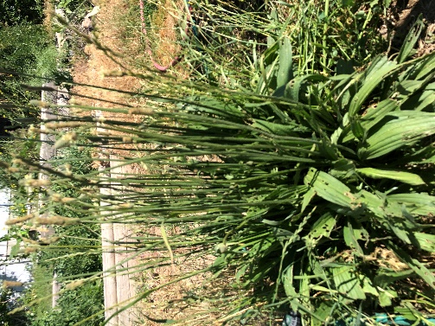
Fig. 45: One-year old narrow leaf plantain
plant
Return to Top

Flax (Linum usitatissimum L.)
- Cool season broadleaf - annual
- Seeds per pound: 82,600
- Upright vertical growth
- Simple tap root
- Fair salt tolerance
- Gown as an interseeded crop with Garbanzo beans
- Plant very fibrous, but livestock eat small seed
- Stem provides long lasting armor (residue)
- Prolific flowering, used by many insects

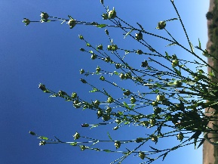 |  | 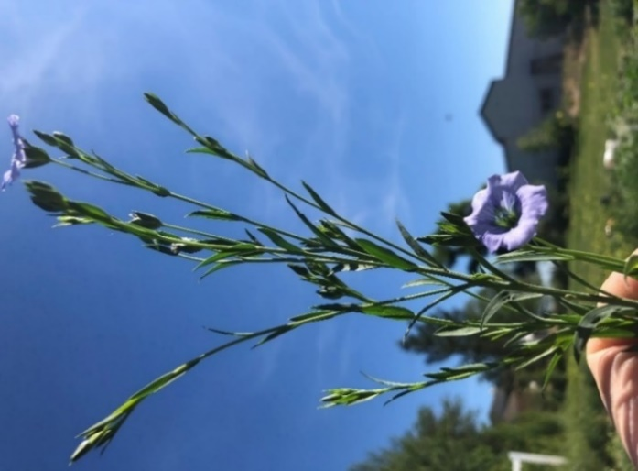
Fig. 46: Flax seed heads starting to mature |  | Fig. 47: Flax just starting to flower
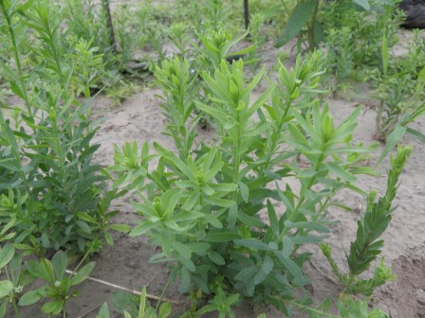 |  | 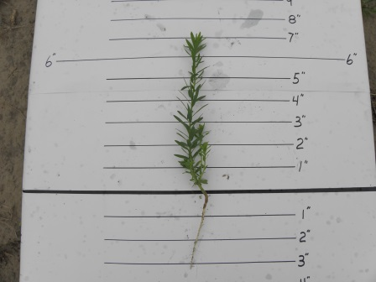
Fig. 48: 30 days after planting |  | Fig. 49: 30 days growth

Return to Top
Beet (Beta vulgaris)
- Cool Season Broadleaf
- Seeds per pound: various based on type
- Biennial or annual types
- Large tap root, excellent nutrient scavenger and leafy tops
- Good salt tolerance
- Self-pollinator
- Many varieties, garden beets, sugar beets, forage beets

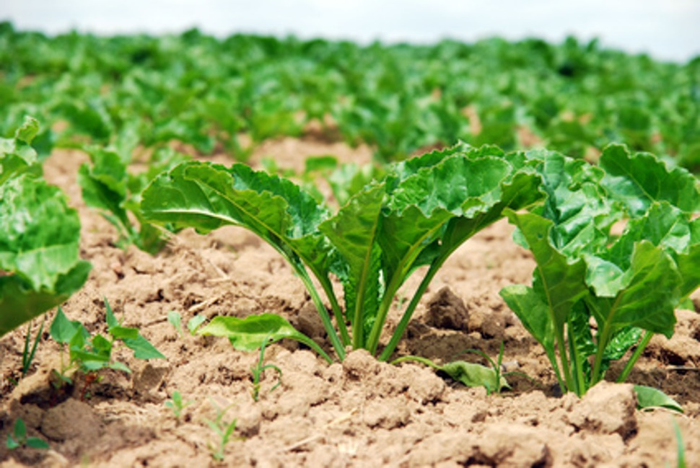
Fig. 50: Young sugar beet plant
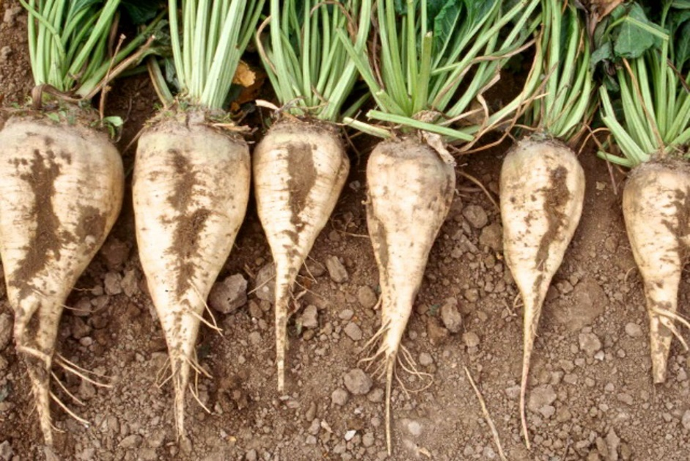
Fig. 51: Sugar beet roots

Return to Top
Alfalfa (Medicago sativa L.)
- Cool season broadleaf - Perennial
- Seeds per pound: 227,000
- Legume, with various winter hardiness scores
- Most types upright, some spreading
- Various leaflet types, multi foliate, large trifoliate
- Poor salt tolerance
- High feed value, but like most legumes can cause bloat
- Deep tap root
- Generally, perennials grow slower than annuals the first year, often out competed in mixes
- Seed can be expensive for cover crop mixes
- Flowers attract insects

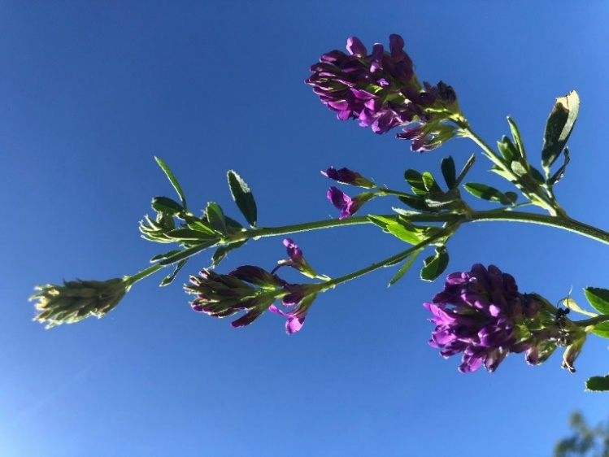 |  | 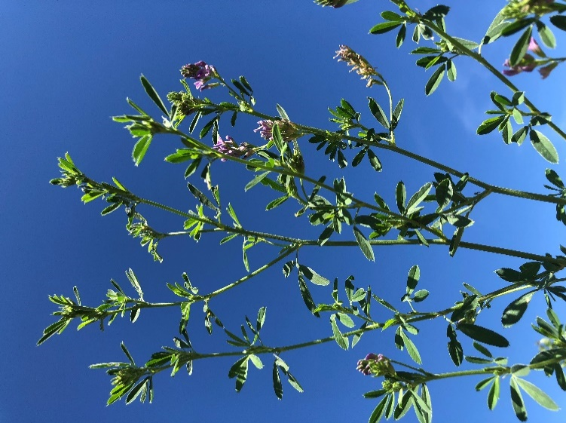
Fig. 52: Alfalfa flowers |  | Fig. 53: Alfalfa is a deep-rooted perennial legume

Return to Top

Perennial Clovers
White Clover (Trifolium repens L.)
- Cool season broadleaf - Perennial
- Seeds per acre: 500,000
- Legume
- Low or prostrate growth
- Often grouped by vertical height (Large, Intermediate, Small)
- Poor salt tolerance
- Slow growth first year, but can become aggressive if not terminated
- Often used as ground cover (living covers) in orchards
- Not often used in tall cover crop mixes

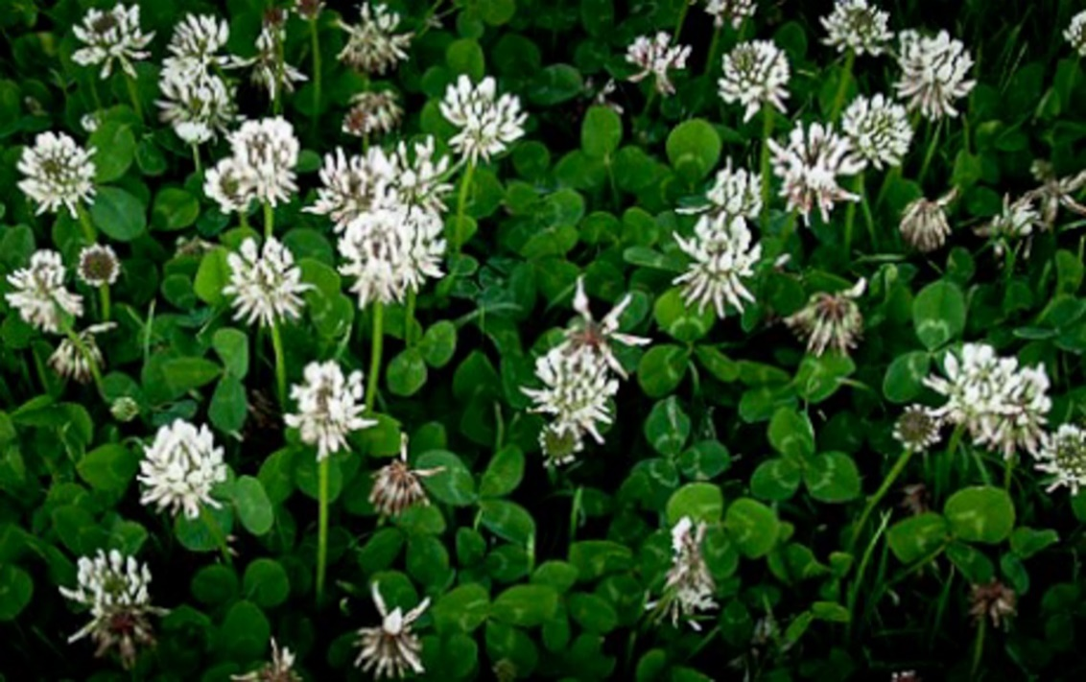
Fig. 54: White clover in full bloom
Return to Top

Alsike Clover (Trifolium hybridum)
- Cool season broadleaf - perennial
- Seeds per pound: 469,000
- Legume, short lived, but reseeds itself like most legumes
- Likes wet or low pH type soils
- Upright growth, but short
- Low drought or heat tolerance
- Some toxicity issues (photosensitization) to horses

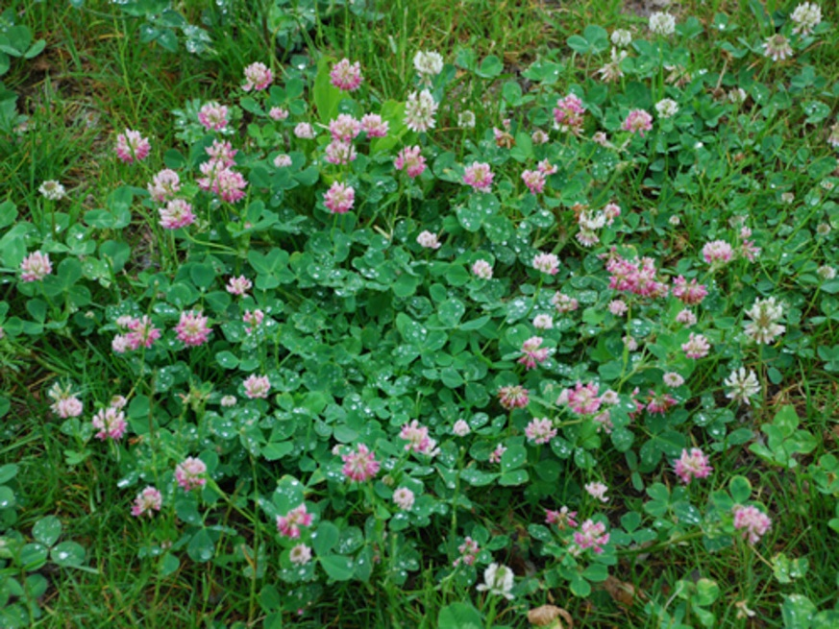
Fig. 55: Alsike clover in full bloom
Return to Top

Red Clover
(Trifolium pretense L.)
- Cool season broadleaf
- Seeds per pound: 240,000
- Short lived perennial legume
- Poor salt tolerance
- Good shade tolerance
- Tap root with branching laterals
- Vertical growth type, tallest of the perennial clovers

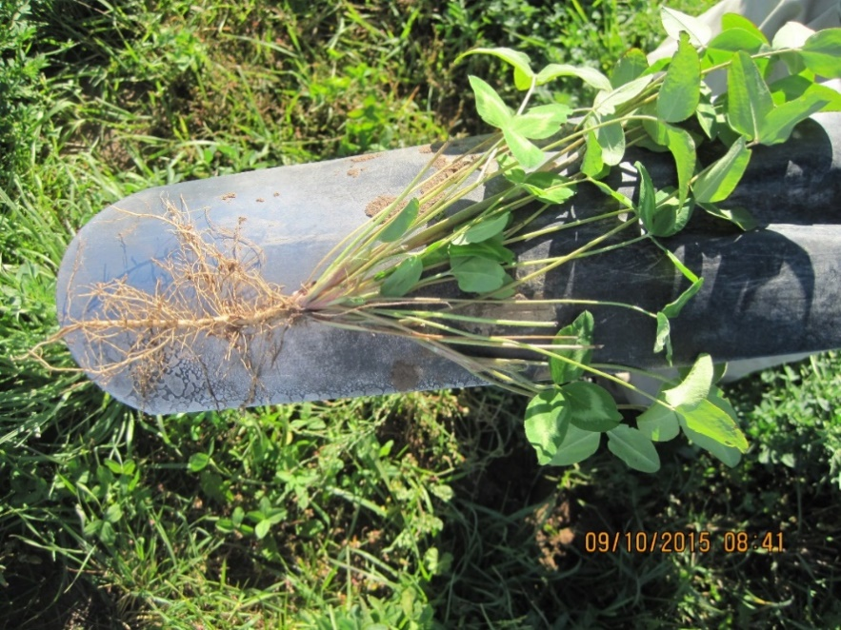 |  | 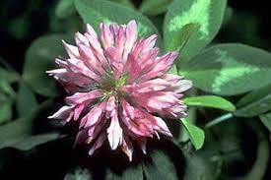
Fig. 56: Red clover plant and root |  | Fig. 56.1: Red clover flower

Return to Top

Annual Clovers
- All cool season legumes, fix nitrogen, tap root
- Flowers attract insects
Berseem Clover (Trifolium alexandrinum L.)
- Upright growth
- Seeds per pound:175,000
- Fair salt tolerance
- High feed quality

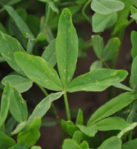 |  | 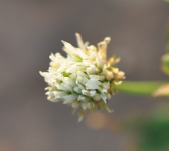
Fig. 57: Berseem clover leaf |  | Fig. 57.1: Berseem clover flower

Return to Top

Balansa Clover (Trifolium Michelianum Savi)
- Survives many soil types and pH
- Seeds per pound: 500,000
- Good shade tolerance
- Shallow tap root system
- Can be interseeded in pastures or hayfields
- Fast germination
- Cold tolerant annual clover, will over winter

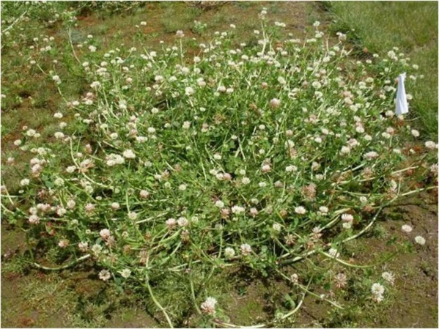
Fig. 58: Mature Balansa clover plant with
flowers
Return to Top

Persian Clover (Trifolium resupinatum)
- Annual, High quality forage, hollow stems, more digestible than alfalfa or red clover
- Seeds per pound: 140,000
- High production early growing season, may produce two harvests if grazing or haying
- Bloat more common due to high digestibility
- Some associated livestock disorders noted in literature

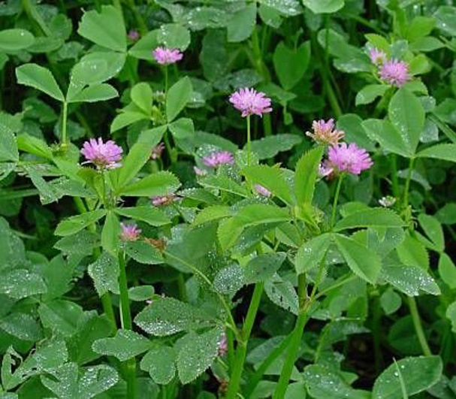
Fig. 59: Persian clover mature plant and
flower
Return to Top

Crimson Clover (Trifolium incarnatum L.)
- Cool season broadleaf - annual
- Upright growth form, fast growing
- Seeds per pound: 150,000
- Not very competitive with tall multi species mix, does well with small grains
- Poor salt tolerance
- Generally, bumble bee pollinated, and utilized by many insects
- Various winter tolerance types, depending on where variety was bred or selected
- Matures early

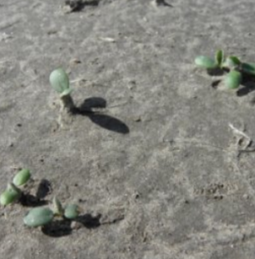 |  | 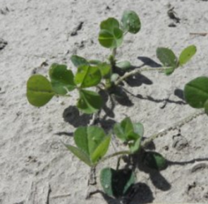
Fig. 60: 24 days after planting |  | Fig. 61: 42 days after planting
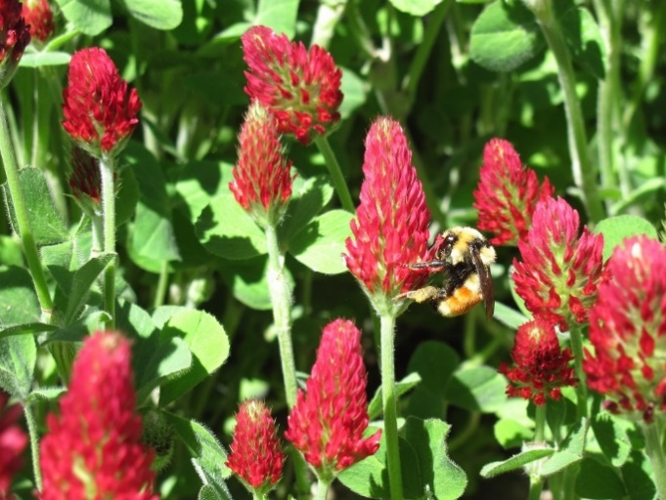 |  | 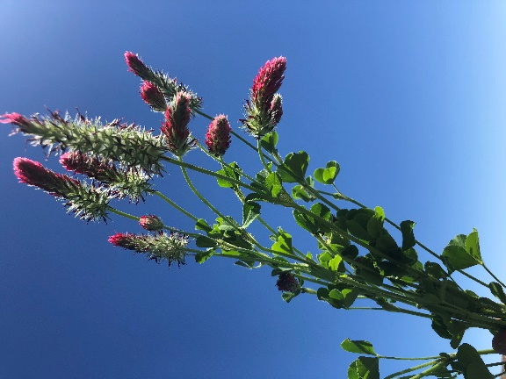
Fig. 62: Crimson clover flower |  | Fig. 63: Crimson clover plant

Return to Top

Sweet Clover (Melilotus sp. L.)
- Cool season broadleaf
- Seeds per pound: 220,000
- Annual (white) or biennial types (yellow), biennial types can overwinter
- Tall upright growth, course stem
- Fair salt tolerance
- Generally, stemmy compared to other clovers or alfalfa, has reduced palatability when mature

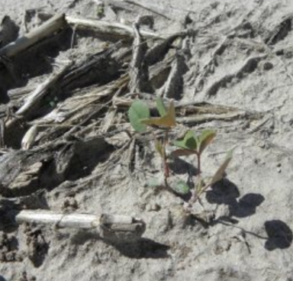 |  | 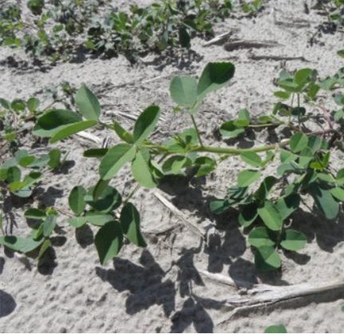
Fig. 64: 42 days after planting |  | Fig. 65: 63 days after planting
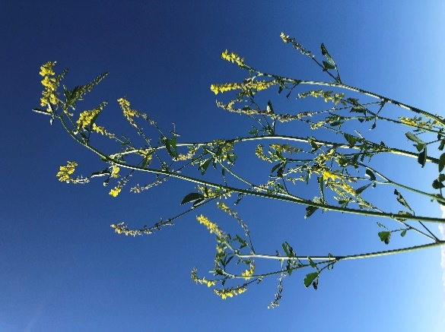
Fig. 66: Yellow sweet clover at
full flower stage

Return to Top

Lentils (Lens culinaris Medik.)
- Cool Season broadleaf - annual
- Seeds per pound: 21,000 various size depends on variety
- Winter Lentil or Spring types
- Not as aggressive as Vetches
- Overwinters more consistently than winter peas
- Upright growth slightly spreading, short growing
- Poor salt tolerance
- Self-pollinated
- High feed quality and very palatable
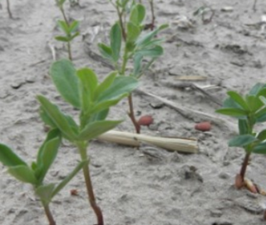 |  | 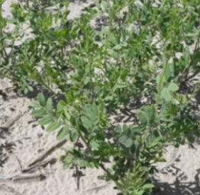
Fig. 67: 30 days after planting |  | Fig. 68: 63 days after planting
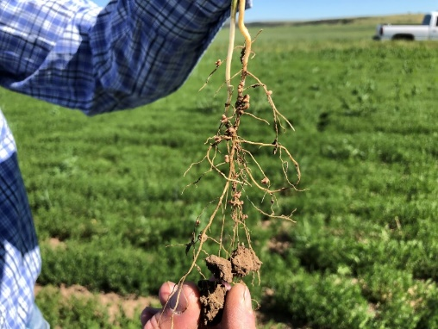 |  | 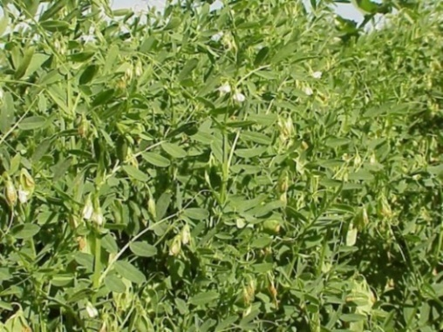
Fig. 69: Lentil root with nodules |  | Fig. 70: Lentil plant
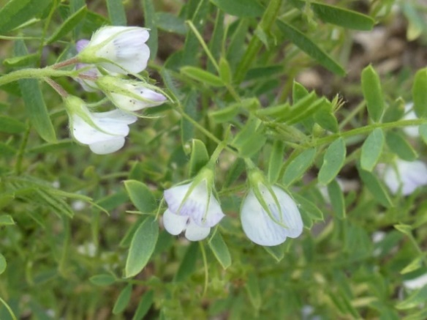
Fig. 71: Lentil blossom
Return to Top
Vetch
Hairy Vetch (Vicia villosa subsp. villosa.)
- Cool Season broadleaf – biannual
- Seeds per pound: 17,700
- Most winter hardy legume
- Excellent Nitrogen fixer
- Hard seeded- so not all seeds will germinate in year planted, check the seed tag if concerned
- Prostrate growth unless it grows up another tall plant
- Poor salt tolerance
- Prolific seed producer if you don’t terminate, will freely reseed itself

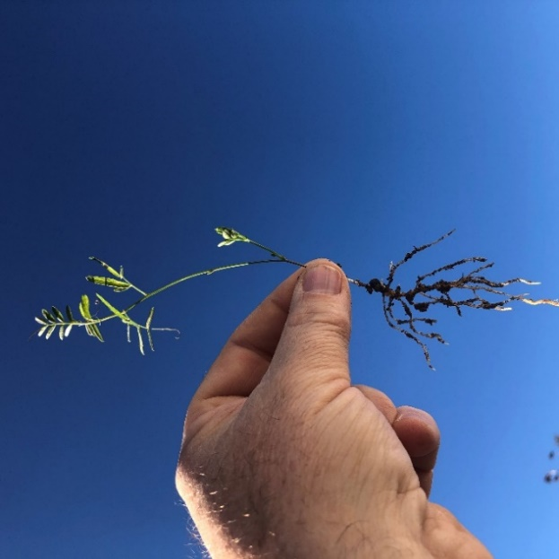 |  | 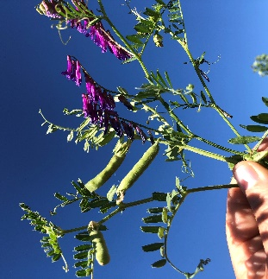
Fig. 72: Hairy vetch seedling |  | Fig. 73: Hairy vetch blossoms and pod development
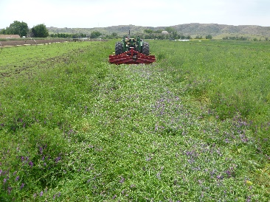
Fig. 74: Roller crimping Hairy vetch
Return to Top
Woolypod Vetch (Vicia villosa ssp. Dasycarpa)
- Cool season broadleaf - annual
- Seeds per pound: 10,000
- Generally, does not overwinter well except in the Southern U.S., better as Spring Annual in northern regions
- Spring annual grows faster than most legumes
- Will climb on other cover crops

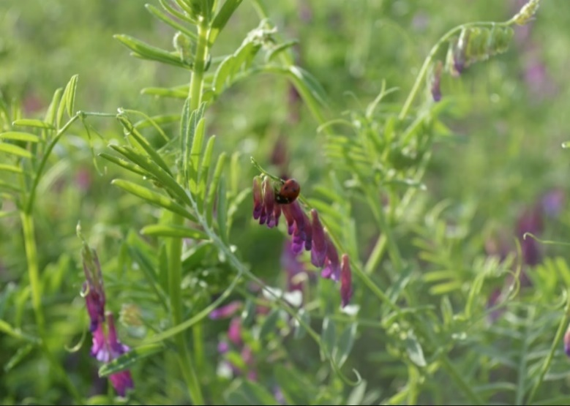 |  | 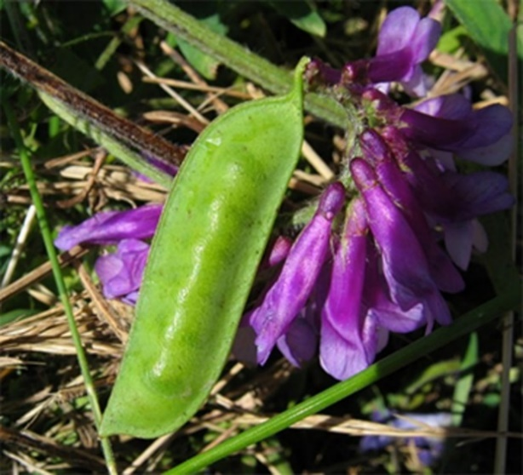
Fig. 75: Woolypod plant and flowers |  | Fig. 76: Woolypod vetch blossom and pod

Return to Top

Common Vetch (Vicia sativa subsp. sativa)
- Cool season broadleaf - annual
- Seeds per pound: 8,000
- Not winter hardy like Hairy vetch
- Climbing type like other vetches, not as aggressive
- Good to plant with taller cover crop mixes
- Good nitrogen producer like other vetches

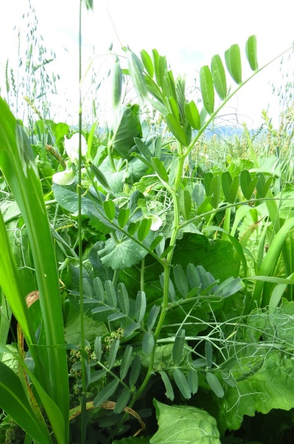 |  | 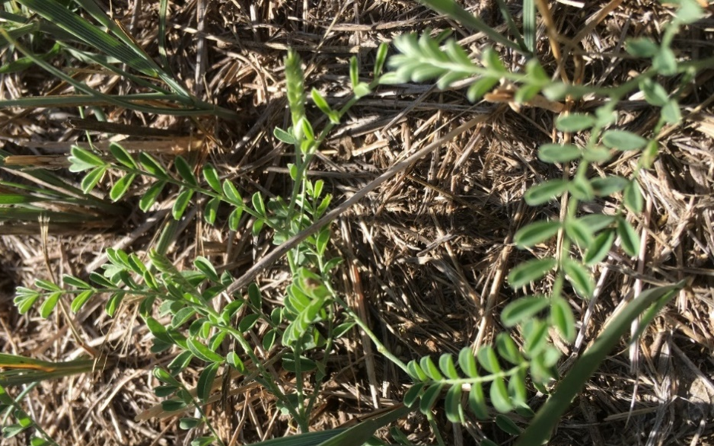
Fig. 77: Common vetch plant in cover crop mix |  | Fig. 78: Common vetch plant

Return to Top

Chickling Vetch (Lathyrus sativus)
- Cool Season Broadleaf - annual
- Seeds per pound: 2,500
- Irregular seed shape (like gravel pebbles)
- Nodulates early
- Seems to grow well under low soil moisture and most soil conditions
- Large seeds need good soil to seed contact

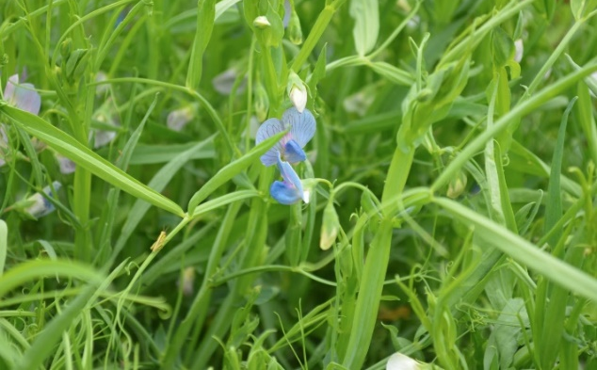 |  | 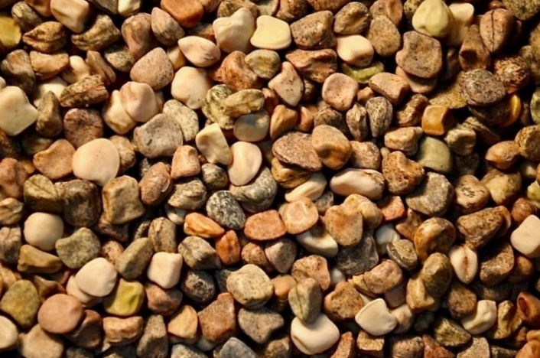
Fig. 79: Chickling vetch plant |  | Fig. 80: Chickling vetch irregular shaped seed
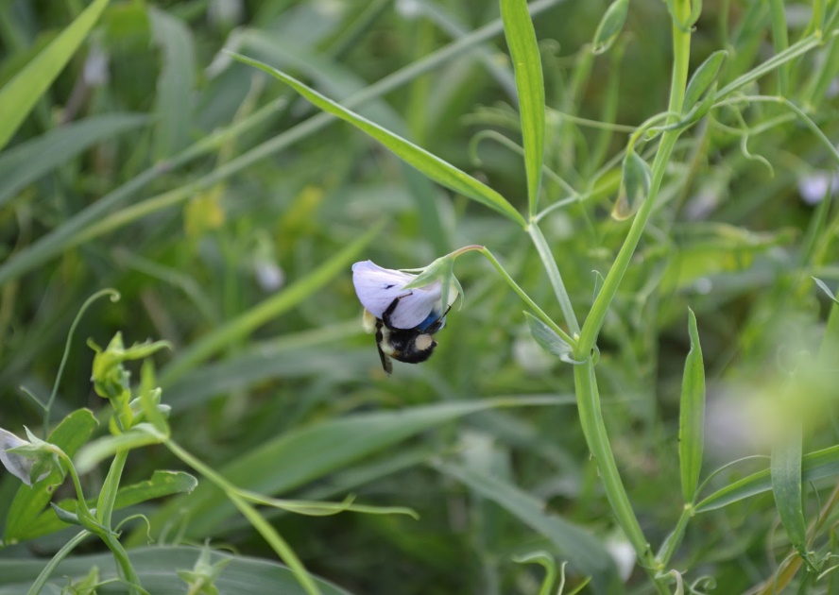
Fig. 81: Chickling vetch flower

Return to Top
Spring Pea (Pisum sativum)
- Cool season broadleaf - annual
- Seeds per pound: 3,100
- Prolific forage production
- Viny growth, forage types will climb up taller species
- Spring peas will winter kill, while winter types like Austrian winter pea will generally over winter except in cold harsh sites.
- There are grain types that generally grow short and strong to resist lodging and forage types that grow tall.
- Poor salt tolerance
- Good feed quality, Pea breeders note that white blossom peas have better palatability

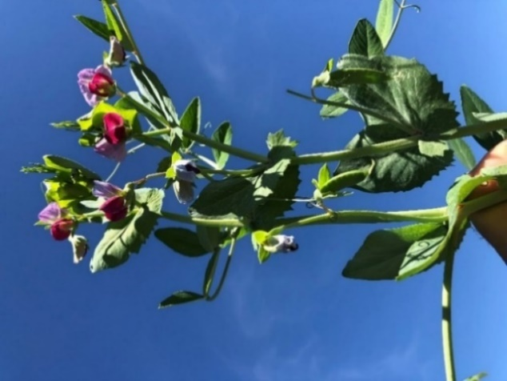 |  | 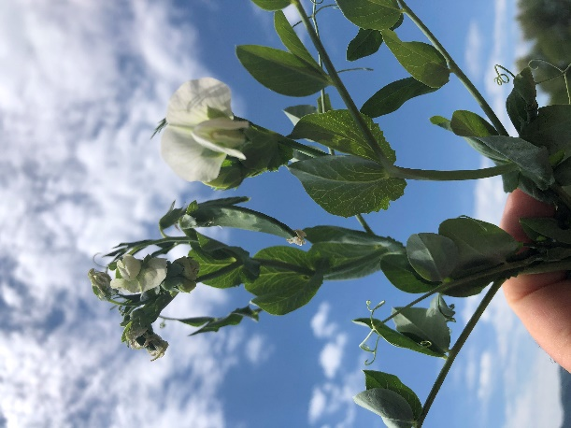
Fig. 82: Spring pea with purple flower |  | Fig. 83 White blossom forage pea
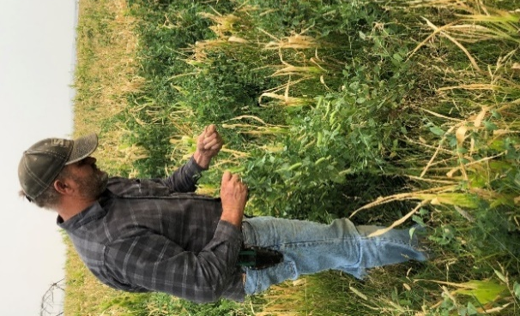 |  | 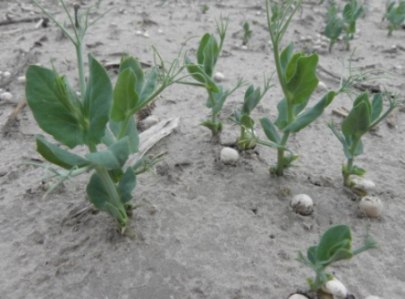
Fig. 84: Pea planted as cover crop with corn |  | Fig. 85: 30 days after planting
Return to Top
Winter Pea (Pisum sativum subsp. Arven)
- Cool season broadleaf - annual
- Seeds per pound: 4,000
- Overwinter in mild winters. Above ground forage will often die in winter but will grow back.
- Prolific forage production
- Poor salt tolerance
- Viny growth, forage types will climb up taller species
- Noted from pea breeders that purple blossom peas are not as palatable as white blossom types
- New WYO Winter Pea, plant deep for better survivability

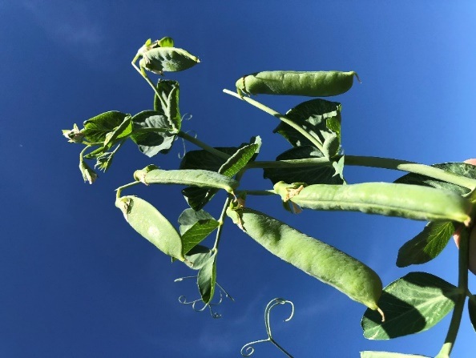 |  | 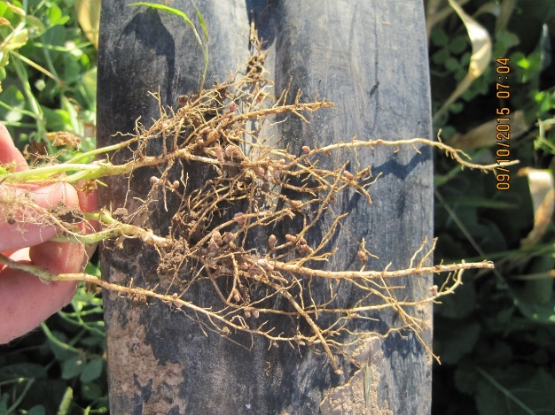
Fig. 86: Winter pea pods |  | Fig. 87: Winter pea roots with nodules
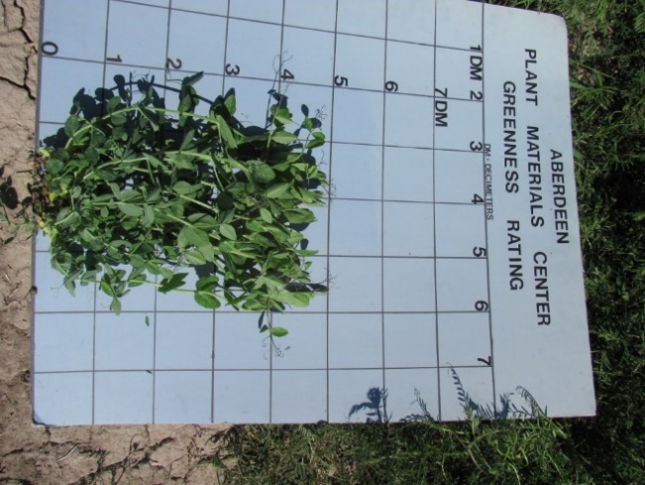 |  | 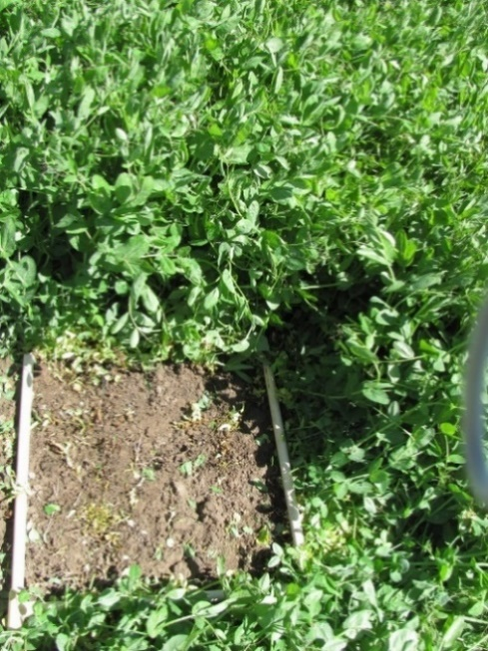
Fig. 88: Winter pea plant |  | Fig. 89: Forage production of winter pea
Return to Top

Chickpeas or Garbanzo Bean (Cicer arietinum)
- Cool Season legume
- Seeds per pound: 2,600
- Two types: Desi and Kabuli: Small, dark desi chickpeas have a yellow interior. Kabuli are large, and beige-colored throughout, with a thin skin. Most cover crops are Desi type due to size.
- Vertical structure with spreading tendency
- Poor salt tolerance
- Have been interseeded with flax in cropping systems

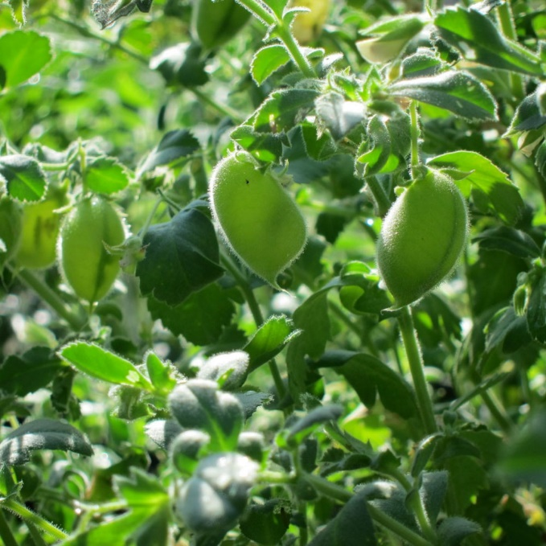
Fig. 90: Chickpea pods
Return to Top

Faba Bean or (Fava Bean) (Vicia faba)
- Cool season broadleaf - annual
- Seeds per pound: 1,700
- Upright plant growth, with course stems
- Very palatable
- Some salt tolerance
- Grows well in vertical type cover crop mixes
- Like all legumes high in protein content when fed to livestock
- Blossoms attract insects (pollinators)

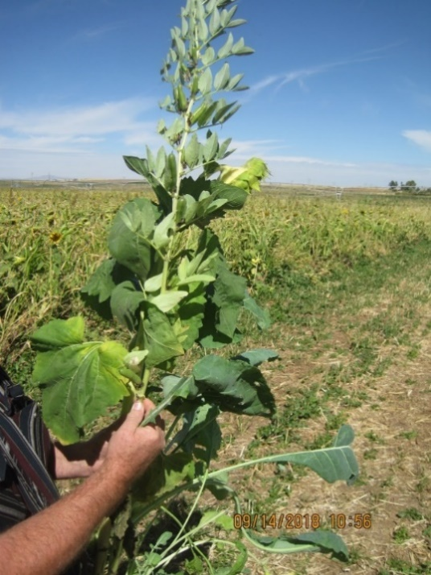 |  | 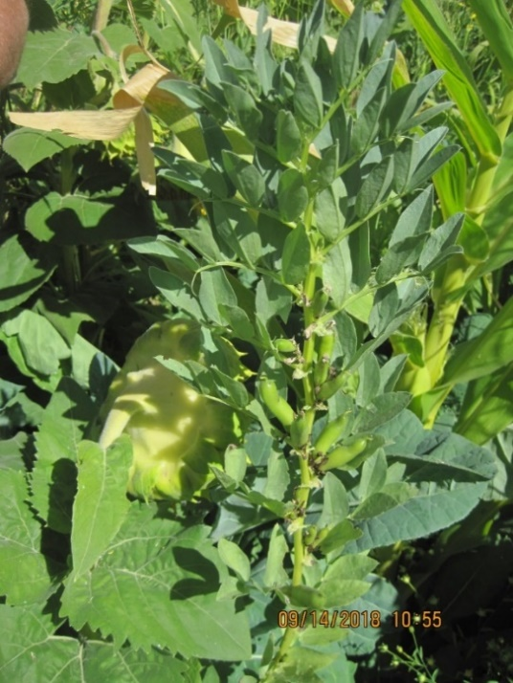
Fig. 91: Faba bean plant |  | Fig. 92: Faba bean plant in cover crop mix
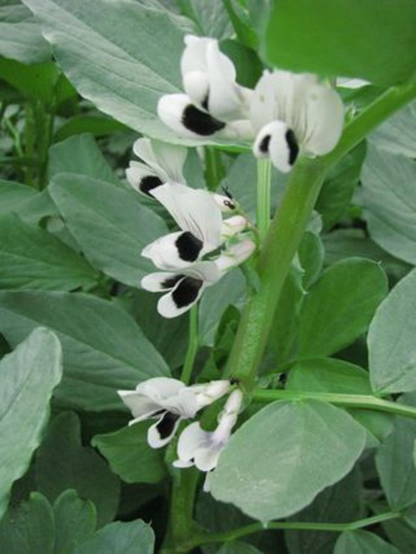
Fig. 93: Faba bean blossom
Return to Top
Sunnhemp (Crotalaria juncea)
- Warm Season broadleaf - annual
- Seeds per pound: 15,000
- Grows tall, and has course stem that is not very palatable at maturity
- Fibrous (stem) plant produces good soil armor
- Can compete well in tall cover crop mixes
- Self pollinates
- Does well in hot climates with plenty of water
- Alkaloids content may be high in some varieties, that limit palatability
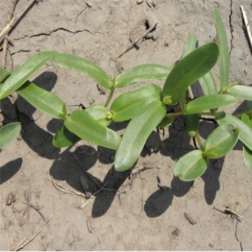 |  | 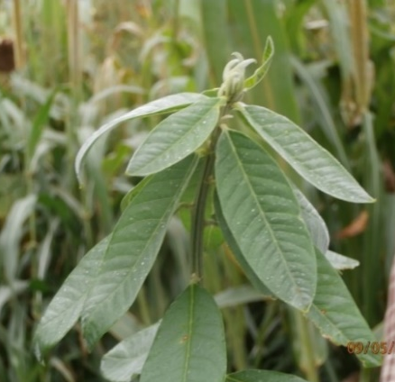
Fig. 94: 6 days after planting |  | Fig. 95: Detail of leaf
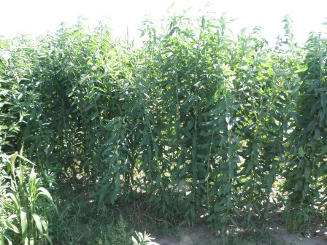
Fig. 96: Sturdy stems can entwine equipment
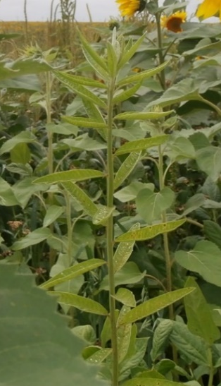 |  | 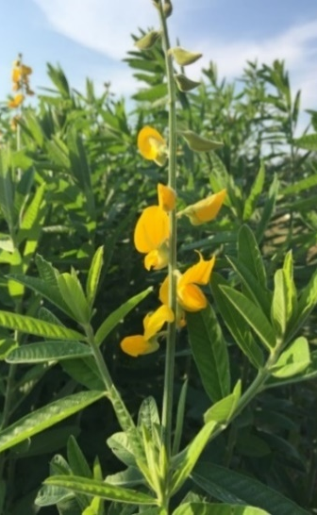
Fig. 97: In a mix Western KS |  | Fig. 98: Sunn hemp blossom
Return to Top
Guar (Cyamopsis tetragonolobus)
- Warm Season Broadleaf - annual
- Seeds per pound: 13,000
- Very drought and heat tolerant
- Good grazing and very nutritional
- Upright growth form
- Very salt tolerant
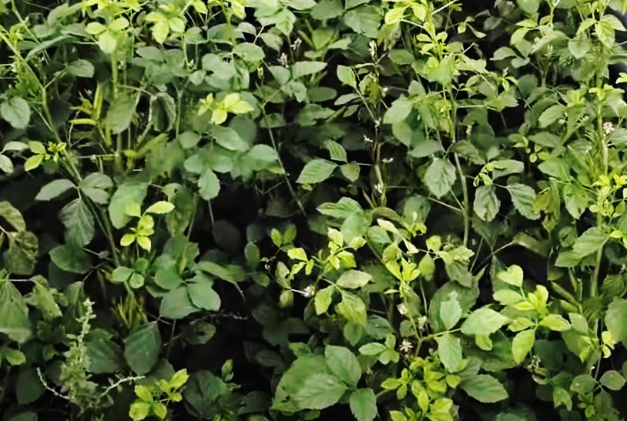 |  | 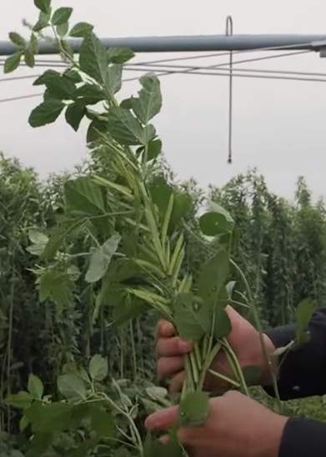
Fig. 99: Guar plant

Fig. 99: Guar plant |  | Fig 99.1: Guar mature plant with pods

Return to Top

Mungbean (Vigna radiata)
- Warm season broadleaf - annual
- Seeds per pound: 7,300
- Upright plant growth, grows like a soybean
- Poor salt tolerance
- Self-pollinated
- Good heat and drought tolerance
- Excellent feed quality
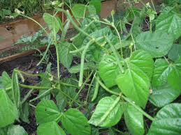 |  | 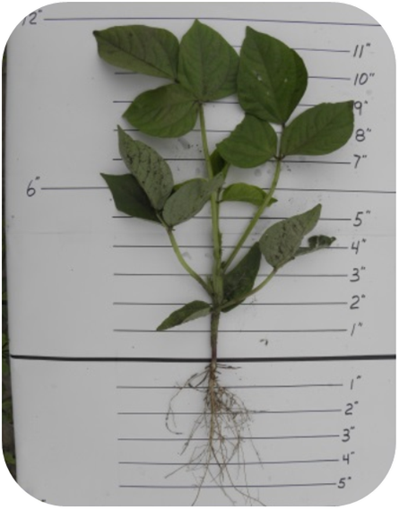
Fig. 100: Mung bean with pods
 |  | Fig. 101: 30 days after planting
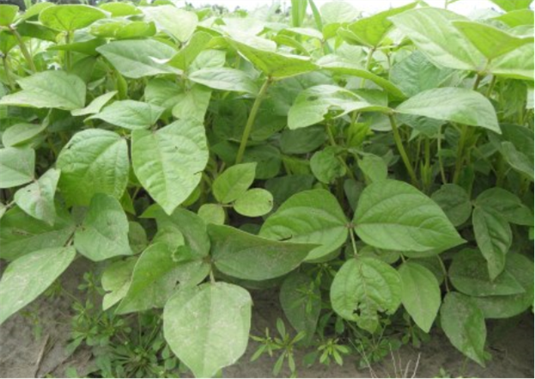
Fig. 102: 30 days after planting
Return to Top
Cowpea (Vigna unguiculate)
- Warm season broadleaf - annual
- Seeds per pound: 4,700 varies on variety
- Tolerates heat and drought
- Upright growth form (like a soybean)
- Other names: southern pea, black-eye pea
- Fair salt tolerance
- Good for grazing, very palatable

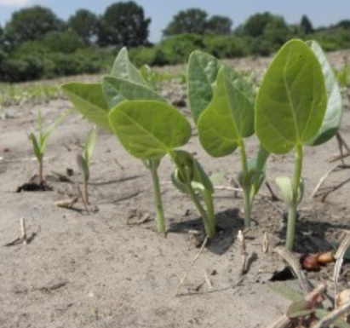 |  | 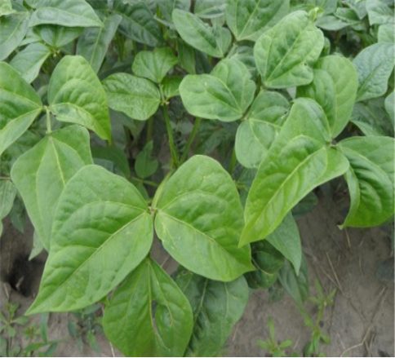
Fig. 103: 6 days after planting |  | Fig. 104: 30 days after planting
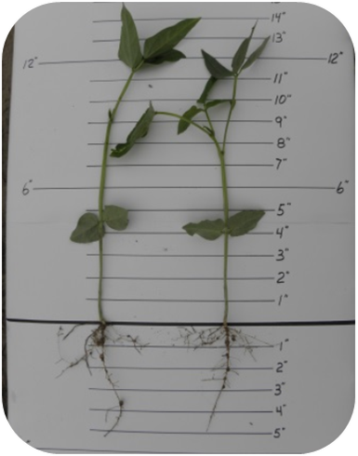
Fig. 105: 30 days after planting

Return to Top

Soybean (Glycine max)
- Warm season broadleaf - annual
- Seeds per pound: 3,000
- Grain and forage types available
- Season of maturity if variable
- High protein content in plant and seed, tells us it fixes large amounts of nitrogen
- Upright and spreading growth type
- Flowers may attract pollinators
- Poor salt tolerance

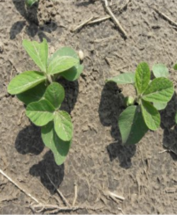 |  | 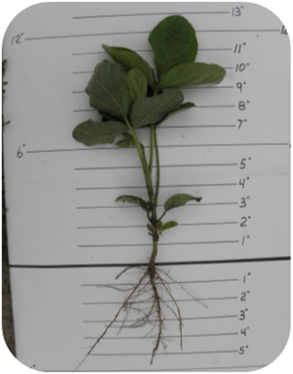
Fig. 106: 15 days after planting |  | Fig. 107: 30 days after planting
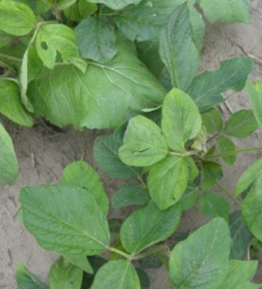
Fig. 108: 30 days after planting

Return to Top
Buckwheat (Fagopyrun esulentum)
- Warm season broadleaf - annual
- Seeds per pound: 20,000
- Vertical growth type, quick cover produced
- Prolific flower production, beneficial for pollinators
- Short life span, flowers in about 60 days, mature in 70-90 days
- Poor salt tolerance
- Known to enhance phosphorus uptake
- Not allowed to be cost shared in some states, causes severe allergies in some people

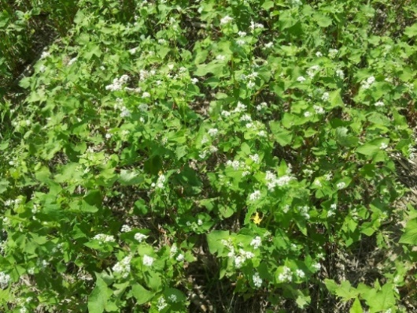 |  | 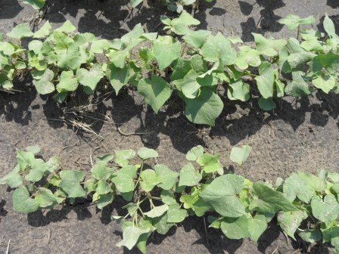
Fig.109: Buckwheat in flower |  | Fig.110:15 days after planting
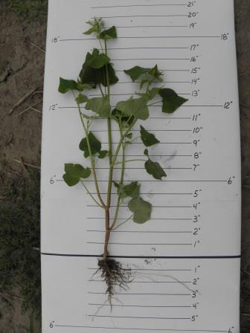 |  | 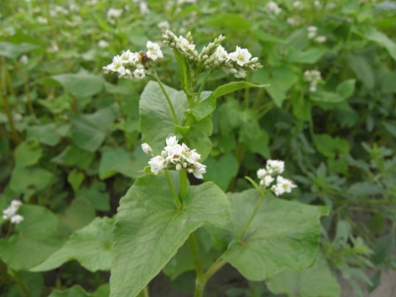  Fig. 112: Buckwheat plant in flower
Fig. 111: 30 days after planting

Return to Top
Safflower (Carthamus tinctorius)
- Warm Season Broadleaf - annual
- Seeds per pound: 15,000
- Deep tap root
- Good salt tolerance
- Good heat and drought tolerance
- Grain type generally has large spines on seed head and leaves, forage type is spineless (Baldy variety)
- Attracts insects
- High oil and energy content in seed, Livestock eat seed heads but leave the stem if no spines
- Strong stem generally stays upright during winter to catch snow drifting

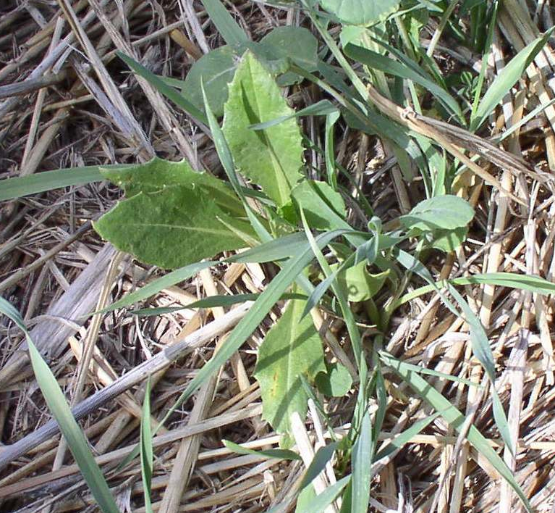 |  | 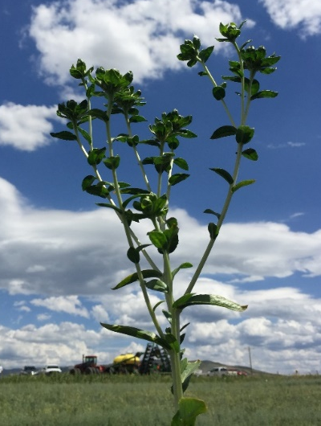
Fig. 113: In a mix in Western KS |  | Fig. 114: New Variety that has no spines called Baldy, spineless
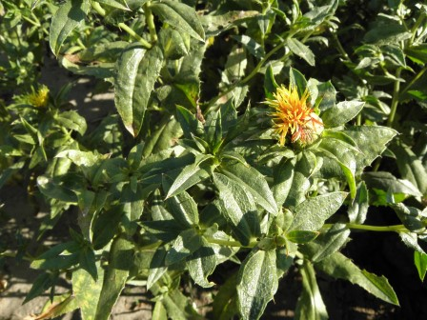
Fig. 115: 62 days after planting

Return to Top

Sunflower (Helianthus annuus)
- Warm season broadleaf -annual
- Seeds per pound: 8,000 (black oil type)
- Generally, cover crops mixes use black oil type instead of the seed eating types
- Tall upright growth with large seed head
- Livestock eat leaves and seed head at maturity, will eat stalk if young
- Deep branching tap root, helps with deep compaction
- Fair salt tolerance
- Many insects utilize the flowering plant

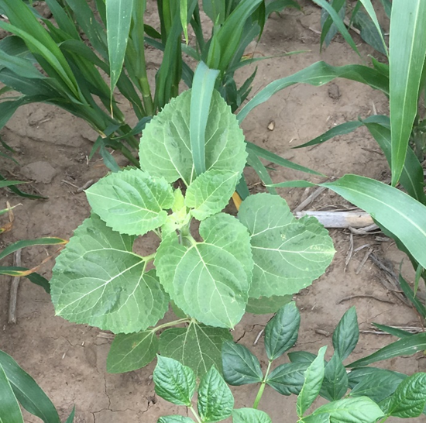 |  | 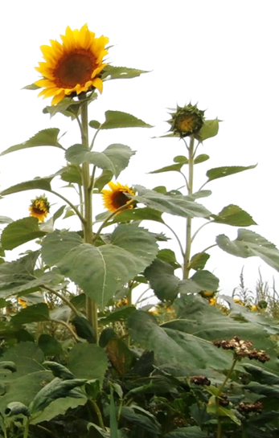
Fig. 116: Sunflower in a mix, Western Kansas |  | Fig. 117: Sunflower plant
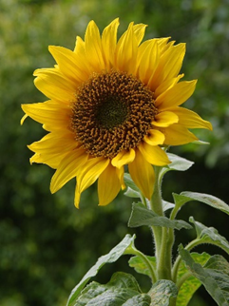
Fig. 118: Sunflower blossom

Return to Top
Okra (Abelmoschus esculentum)
- Warm Season broadleaf - annual
- Seeds per pound: 7,200
- Tall vertical growth
- Heat and drought tolerant
- Good livestock palatability, stems good snow catch
- Deep tap root with good side branching

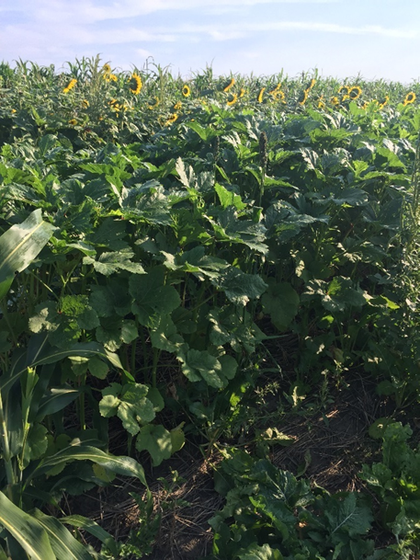
Fig. 119 Okra in cover crop plots

Return to Top

Cucurbits-Melons & Squash
- Warm season broadleaf - annual
- Various types include small watermelon, cucumber, pumpkin
- Viny horizontal growth but often will grow up the canopy of mixes
- Livestock and wildlife eat fruit and leafy vines
- Unique leaf / plant structure in cover crop mixes
- Insects utilize flowers

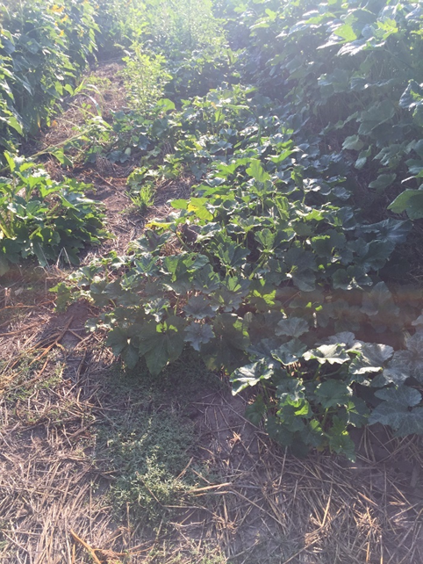
Fig. 120: Squash and melons in no till cover crop plots

Return to Top

Teff (Eragrostis tef)
- Warm season grass - annual
- Seeds per pound: 1.3 million, some are sold coated at about 600,000
- Annual, with upright growth
- High quality forage, fine stem, makes great grass hay
- Poor salt tolerance
- Like all grasses self-pollinated (wind)

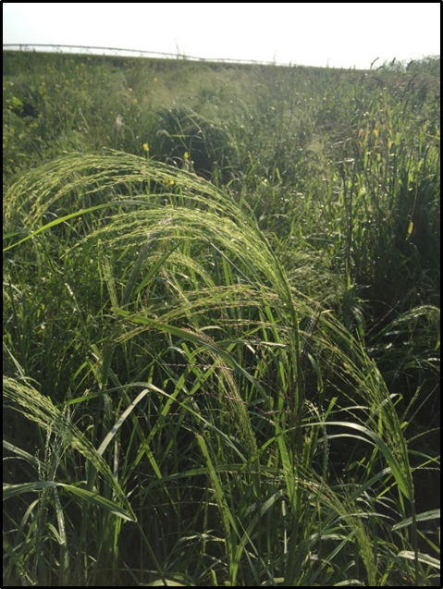 |  | 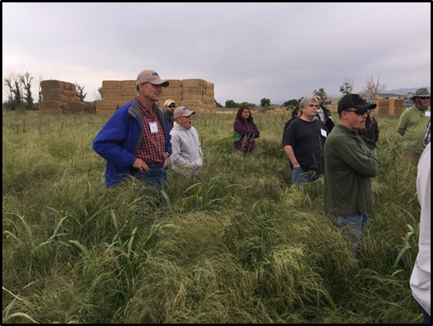  Fig. 122: Teff in the cover crop mix
Fig. 121: Mature Teff plant showing seed head

Return to Top

Millets
Brown Top Millet (Urochloa ramosa (L.) Nguyen)
- Warm season grass - annual
- Seeds per pound: 180,000
- Long season
- Up right growth form 3 – 4 feet tall
- Rapid growth rates
- Fine stem and leaves dry down well for hay production
- Utilized to help stabilize erosive hill slopes
- Great for wildlife food plots
- Most often used in the South US as it requires a long growing season

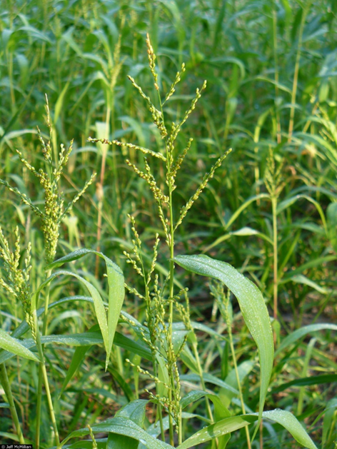
Fig. 123: Mature brown top millet plant

Return to Top

German Millet/Foxtail Millet (Setaria italica)
- Warm season grass – annual
- Seeds per pound: 180,000
- Not the highest yielding Millet
- Feed Quality is high if grazed before seeds head out
- Most drought tolerant Millet
- Fast growing, often used for hay production
- No Prussic Acid issues, but can cause joint problems in horses

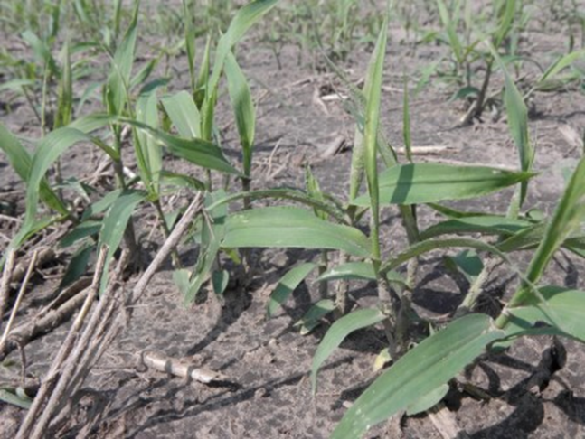 |  | 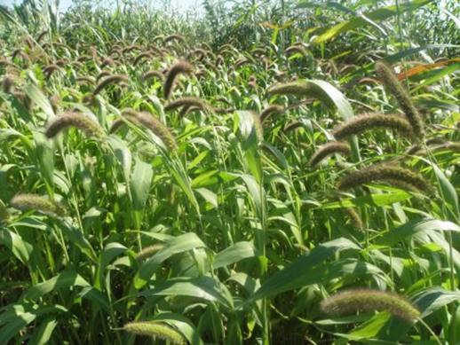
Fig. 125: 15 days after planting |  | Fig. 124: Mature German millet plant with seed heads
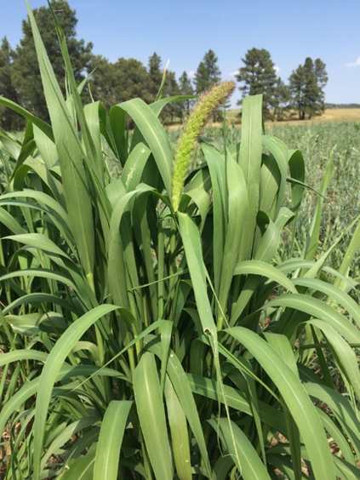
Fig. 126: German Millet tillers

Return to Top

Pearl Millet (Pennisetum americanum)
- Warm season grass - annual
- Seeds per pound: 82,000
- Higher yielding Millet but slower growing, loves the heat conditions
- Heat and drought tolerant, loves warm night temperatures
- Grows 3-7 feet tall
- Poor salt tolerance
- Does not hold nutritional value as well as Sorghum in the winter after frost but no prussic acid issues

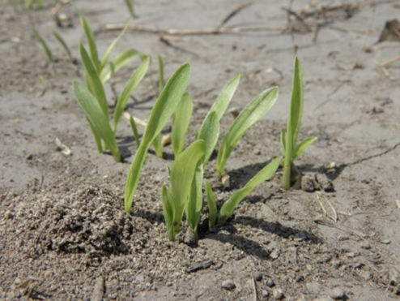 |  | 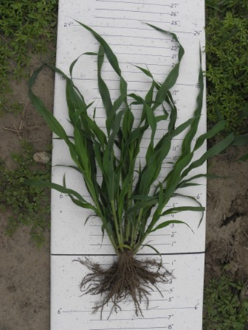
Fig. 127: 6-day old seedling |  | Fig.128: 30 days old in vegetative stage
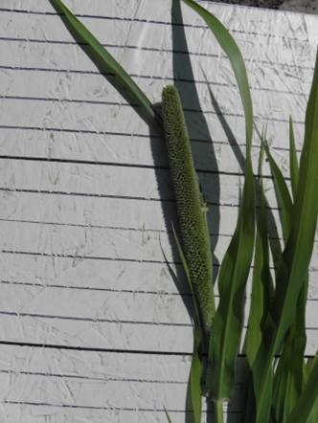
Fig. 129: Pearl Millet seed head

Return to Top
Proso Millet (Panicum miliaceum)
- Warm season grass - annual
- Seeds per pound: 82,300
- Fastest Growing Millet, short life cycle, will be one of the first to set mature seed in a mix
- Livestock will eat the seeds and generally leave the stalk at maturity
- Not as high feed quality as German millet but still good
- Great wildlife species for mixes

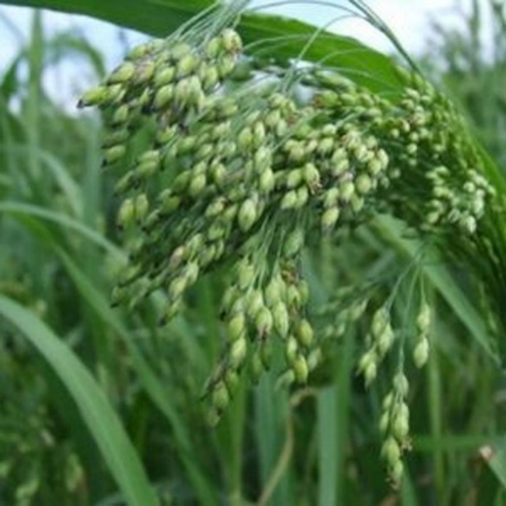
Fig. 130: Proso Millet seed head

Return to Top

Sorghum Sudan Species
- Warm season grasses – annual
- Includes: Sudan Grass, Forage Sorghum, Sorghum x Sudan
- Seeds per pound: 16,000 – 20,000 depending on type
- Contains prussic acid, has not been a common problem when in mixes but as monoculture could be problems. Sorghums have more prussic acid than Sudan grass types or hybrids.
- Fair salt tolerance
- Good fibrous root structure
- Excellent for developing granular structure like most grasses
- At maturity livestock my only eat leaves and mash stems to the ground for soil armor
- Many types have Brown Mid Rib (BMR) traits. BMR has more digestible fiber. Many characteristics; Photoperiod Sensitive, Male Sterile, Delayed Maturity, Brachytic Dwarf

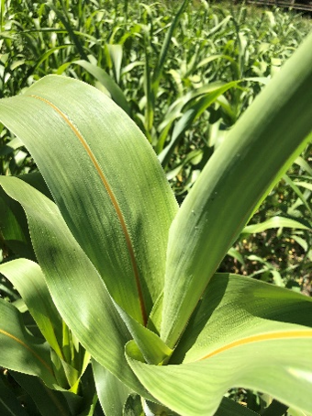 |  | 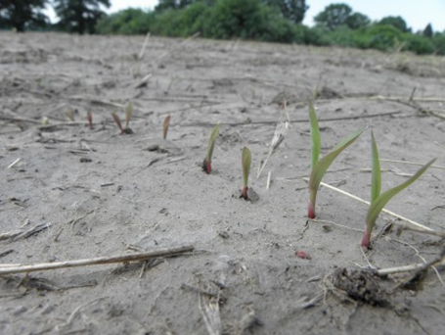  Fig. 132: 6-Days Growth
Fig. 131: Brown Mid Rib trait
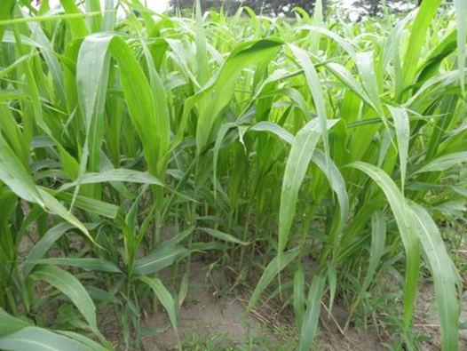 |  | 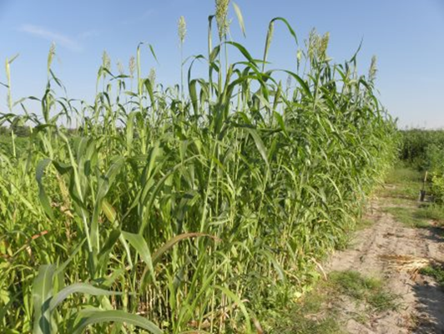
Fig. 133: 30 days old in vegetative stage |  | Fig. 134: At Maturity

Return to Top
Grain Sorghum (Sorghum bicolor L. Moench)
- Warm season grass - annual
- Seeds per pound: 16,000
- Shorter growth form, with large seed head
- Heat and drought tolerant
- Contains prussic acid
- Fair salt tolerance

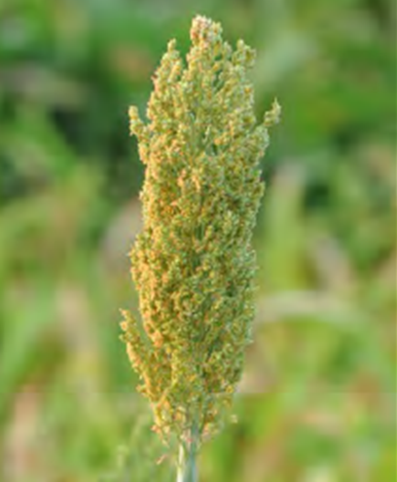 |  | 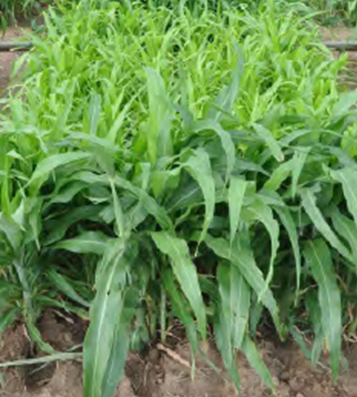
Fig. 135: Grain Sorghum seed head |  | Fig. 136: Grain Sorghum vegetative stage

Return to Top

Corn, Forage (Zea mays L.)
- Warm Season grass - annual
- Seeds per pound: 2,500 varies with variety or type
- Various types, male sterile, no kernels formed, to short grazing types
- Good palatability,
- Poor salt tolerance
- BMR grazing traits available

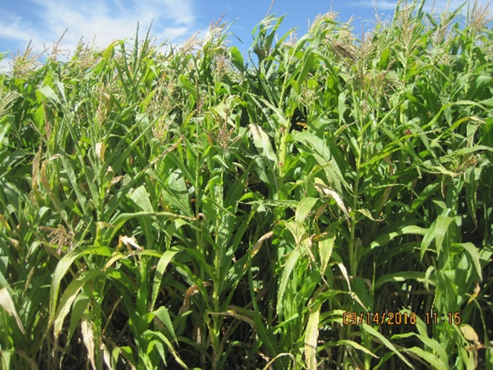 |  | 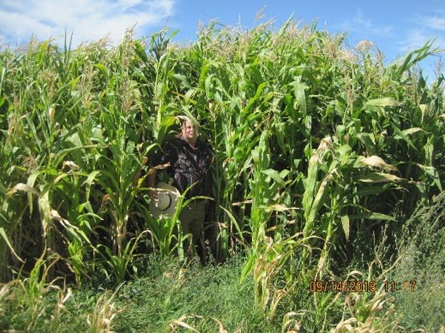
Fig. 137: Male sterile corn |  | Fig. 138: Male sterile corn for grazing

Return to Top

Photo Credits:
1 – 4, 6, 8, 10, 13, 17, 22-25, 29-30, 33-35, 38-39, 42, 45-47, 52-53, 56, 62-63, 66, 69, 72-74, 77, 82-84, 86-89, 91-92, 98, 114, 119-122, 124, 126, 131, 138: Marlon Winger, USDA- NRCS
91, 137-138: Cameron Williams, USDA-NRCS
9, 11, 14-15, 43-44, 95, 97, 113, 116-117: Tanya Allemang, USDA-NRCS
23.1: Tim Weltmer, USDA-NRCS
5, 21, 50-51, 54, 55, 57-59, 70-71, 75-76, 79-81, 90, 93, 99, 99.1 118, 123, 130: Keith Burns, Green Cover Seed, Bladen, NE
7, 12, 15.1, 18-20, 21.1-21.3, 26-28, 31-32, 36, 37, 40, 41, 48, 49, 56.1, 57-57.1, 60, 61, 64, 65, 67, 68, 78, 85, 94, 96, 101-112, 115, 125, 127-129, 132-136: USDA - NRCS

